UNITED  NATIONS |  |  | 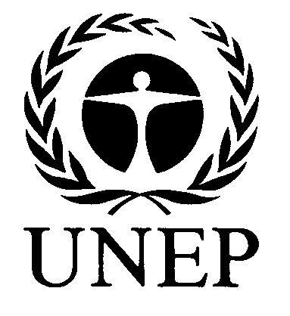 |  | 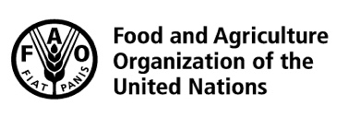 |  |  | BES
 |  |  |  |  |  |  | IPBES/7/10/Add.1
 |  | Intergovernmental Science-Policy Platform on Biodiversity and Ecosystem Services |  |  |  |  | Distr.: General  29 May 2019  Original: English
Plenary of the Intergovernmental Science-Policy
Platform on Biodiversity and Ecosystem Services
Seventh session
Paris, 29 April–4 May 2019
Report of the Plenary of the Intergovernmental Science-Policy Platform on Biodiversity and Ecosystem Services on the work of its seventh session
Addendum
Summary for policymakers of the global assessment report on biodiversity and ecosystem services of the Intergovernmental Science-Policy Platform on Biodiversity and Ecosystem Services
At its seventh session, in its decision IPBES-7/1, section II, paragraph 1 the Plenary of the Intergovernmental Science-Policy Platform on Biodiversity and Ecosystem Services (IPBES) approved the summary for policymakers of the global assessment of biodiversity and ecosystem services as set out in the annex to the present addendum.

Annex
Summary for policymakers of the global assessment report on biodiversity and ecosystem services of the Intergovernmental Science-Policy Platform on Biodiversity and Ecosystem Services
Authors
Sandra Díaz (Co-Chair, Argentina), Josef Settele (Co-Chair, Germany), Eduardo Brondízio (Co-Chair, Brazil/United States of America)
Hien T. Ngo (IPBES), Maximilien Guèze (IPBES); John Agard (Trinidad and Tobago), Almut Arneth (Germany), Patricia Balvanera (Mexico), Kate Brauman (United States of America), Stuart Butchart (United Kingdom of Great Britain and Northern Ireland/BirdLife International), Kai Chan (Canada), Lucas A. Garibaldi (Argentina), Kazuhito Ichii (Japan), Jianguo Liu (United States of America), Suneetha Mazhenchery Subramanian (India/United Nations University), Guy F. Midgley (South Africa), Patricia Miloslavich (Bolivarian Republic of Venezuela/Australia), Zsolt Molnár (Hungary), David Obura (Kenya), Alexander Pfaff (United States of America), Stephen Polasky (United States of America), Andy Purvis (United Kingdom of Great Britain and Northern Ireland), Jona Razzaque (Bangladesh/United Kingdom of Great Britain and Northern Ireland), Belinda Reyers (South Africa), Rinku Roy Chowdhury (United States of America), Yunne-Jai Shin (France),
Ingrid Visseren-Hamakers (Netherlands/United States of America), Katherine Willis (United Kingdom of Great Britain and Northern Ireland), Cynthia Zayas (Philippines)
Members of the management committee who provided guidance for the production of this assessment
Robert T. Watson, Ivar A. Baste, Anne Larigauderie, Paul Leadley, Unai Pascual, Brigitte Baptiste, Sebsebe Demissew, Luthando Dziba, Günay Erpul, Asghar Fazel, Markus Fischer, Ana María Hernández, Madhav Karki, Vinod Mathur, Tamar Pataridze, Isabel Sousa Pinto, Marie Stenseke, Katalin Török, Bibiana Vilá
Overall review editors
Manuela Carneiro da Cunha, Georgina M. Mace, Harold Mooney
Disclaimer:
The designations employed and the presentation of material on the maps used in the present report do not imply the expression of any opinion whatsoever on the part of the Intergovernmental
Science-Policy Platform on Biodiversity and Ecosystem Services concerning the legal status of any country, territory, city or area or of its authorities, or concerning the delimitation of its frontiers or boundaries. These maps have been prepared for the sole purpose of facilitating the assessment of the broad biogeographical areas represented therein.

Key messages
A. Nature and its vital contributions to people, which together embody biodiversity and ecosystem functions and services, are deteriorating worldwide.
Nature embodies different concepts for different people, including biodiversity, ecosystems, Mother Earth, systems of life and other analogous concepts. Nature’s contributions to people embody different concepts, such as ecosystem goods and services and nature’s gifts. Both nature and nature’s contributions to people are vital for human existence and good quality of life (human well-being, living in harmony with nature, living well in balance and harmony with Mother Earth, and other analogous concepts).While more food, energy and materials than ever before are now being supplied to people in most places, this is increasingly at the expense of nature’s ability to provide such contributions in the future, and frequently undermines nature’s many other contributions, which range from water quality regulation to sense of place. The biosphere, upon which humanity as a whole depends, is being altered to an unparalleled degree across all spatial scales. Biodiversity – the diversity within species, between species and of ecosystems – is declining faster than at any time in human history.
A1 Nature is essential for human existence and good quality of life. Most of nature’s contributions to people are not fully replaceable, and some are irreplaceable. Nature plays a critical role in providing food and feed, energy, medicines and genetic resources and a variety of materials fundamental for people’s physical well-being and for maintaining culture. For example, more than 2 billion people rely on wood fuel to meet their primary energy needs, an estimated 4 billion people rely primarily on natural medicines for their health care and some 70 per cent of drugs used for cancer are natural or are synthetic products inspired by nature. Nature, through its ecological and evolutionary processes, sustains the quality of the air, fresh water and soils on which humanity depends, distributes fresh water, regulates the climate, provides pollination and pest control and reduces the impact of natural hazards. For example, more than 75 per cent of global food crop types, including fruits and vegetables and some of the most important cash crops, such as coffee, cocoa and almonds, rely on animal pollination. Marine and terrestrial ecosystems are the sole sinks for anthropogenic carbon emissions, with a gross sequestration of 5.6 gigatons of carbon per year (the equivalent of some 60 per cent of global anthropogenic emissions). Nature underpins all dimensions of human health and contributes to non-material aspects of quality of life – inspiration and learning, physical and psychological experiences, and supporting identities – that are central to quality of life and cultural integrity, even if their aggregated value is difficult to quantify. Most of nature’s contributions are co-produced with people, but while anthropogenic assets – knowledge and institutions, technology infrastructure and financial capital – can enhance or partially replace some of those contributions, some are irreplaceable. The diversity of nature maintains humanity’s ability to choose alternatives in the face of an uncertain future.
A2 Nature’s contributions to people are often distributed unequally across space and time and among different segments of society. There are often trade-offs in the production and use of nature’s contributions. Benefits and burdens associated with co-production and use of nature’s contributions are distributed and experienced differently among social groups, countries and regions. Giving priority to one of nature’s contributions to people, such as food production, can result in ecological changes that reduce other contributions. Some of these changes may benefit some people at the expense of others, particularly the most vulnerable, as may changes in technological and institutional arrangements. For example, although food production today is sufficient to satisfy global needs, approximately 11 per cent of the world’s population is undernourished, and diet-related disease drives 20 per cent of premature mortality, related both to undernourishment and to obesity. The great expansion in the production of food, feed, fibre and bioenergy has occurred at the cost of many other contributions of nature to quality of life, including regulation of air and water quality, climate regulation and habitat provision. Synergies also exist, such as sustainable agricultural practices that enhance soil quality, thereby improving productivity and other ecosystem functions and services, such as carbon sequestration and water quality regulation.
A3 Since 1970, trends in agricultural production, fish harvest, bioenergy production and harvest of materials have increased, but 14 of the 18 categories of contributions of nature that were assessed, mostly regulating and non-material contributions, have declined. The value of agricultural crop production ($2.6 trillion in 2016) has increased approximately threefold since 1970 and raw timber harvest has increased by 45 per cent, reaching some 4 billion cubic metres in 2017, with the forestry industry providing about 13.2 million jobs. However, indicators of regulating contributions, such as soil organic carbon and pollinator diversity, have declined, indicating that gains in material contributions are often not sustainable. Currently, land degradation has reduced productivity in 23 per cent of the global terrestrial area, and between $235 billion and $577 billion in annual global crop output is at risk as a result of pollinator loss. Moreover, loss of coastal habitats and coral reefs reduces coastal protection, which increases the risk from floods and hurricanes to life and property for the 100 million to 300 million people living within coastal 100-year flood zones.
A4 Nature across most of the globe has now been significantly altered by multiple human drivers, with the great majority of indicators of ecosystems and biodiversity showing rapid decline. Seventy-five per cent of the land surface is significantly altered, 66 per cent of the ocean area is experiencing increasing cumulative impacts, and over 85 per cent of wetlands (area) has been lost. While the rate of forest loss has slowed globally since 2000, this is distributed unequally. Across much of the highly biodiverse tropics, 32 million hectares of primary or recovering forest were lost between 2010 and 2015. The extent of tropical and subtropical forests is increasing within some countries, and the global extent of temperate and boreal forests is increasing. A range of actions – from restoration of natural forest to planting of monocultures – contributes to these increases, but these actions have very different consequences for biodiversity and its contributions to people. Approximately half the live coral cover on coral reefs has been lost since the 1870s, with accelerating losses in recent decades due to climate change exacerbating other drivers. The average abundance of native species in most major terrestrial biomes has fallen by at least 20 per cent, potentially affecting ecosystem processes and hence nature’s contributions to people; this decline has mostly taken place since 1900 and may be accelerating. In areas of high endemism, native biodiversity has often been severely impacted by invasive alien species. Population sizes of wild vertebrate species have tended to decline over the last 50 years on land, in freshwater and in the sea. Global trends in insect populations are not known but rapid declines have been well documented in some places. {BG 4, 5}
A5 Human actions threaten more species with global extinction now than ever before. An average of around 25 per cent of species in assessed animal and plant groups are threatened (Figure SPM.3), suggesting that around 1 million species already face extinction, many within decades, unless action is taken to reduce the intensity of drivers of biodiversity loss. Without such action, there will be a further acceleration in the global rate of species extinction, which is already at least tens to hundreds of times higher than it has averaged over the past 10 million years. {Figure SPM.4, BG 6}
A6 Globally, local varieties and breeds of domesticated plants and animals are disappearing. This loss of diversity, including genetic diversity, poses a serious risk to global food security by undermining the resilience of many agricultural systems to threats such as pests, pathogens and climate change. Fewer and fewer varieties and breeds of plants and animals are being cultivated, raised, traded and maintained around the world, despite many local efforts, which include those by indigenous peoples and local communities. By 2016, 559 of the 6,190 domesticated breeds of mammals used for food and agriculture (over 9 per cent) had become extinct and at least 1,000 more are threatened. In addition, many crop wild relatives that are important for long-term food security lack effective protection, and the conservation status of wild relatives of domesticated mammals and birds is worsening. Reductions in the diversity of cultivated crops, crop wild relatives and domesticated breeds mean that agroecosystems are less resilient against future climate change, pests and pathogens.
A7 Biological communities are becoming more similar to each other in both managed and unmanaged systems within and across regions. This human-caused process leads to losses of local biodiversity, including endemic species, ecosystem functions and nature’s contributions to people.
A8 Human-induced changes are creating conditions for fast biological evolution - so rapid that its effects can be seen in only a few years or even more quickly. The consequences can be positive or negative for biodiversity and ecosystems, but can create uncertainty about the sustainability of species, ecosystem functions and the delivery of nature’s contributions to people. Understanding and monitoring these biological evolutionary changes is as important for informed policy decisions as it is in cases of ecological change. Sustainable management strategies then can be designed to influence evolutionary trajectories so as to protect vulnerable species and reduce the impact of unwanted species (such as weeds, pests or pathogens). The widespread declines in geographic distribution and population sizes of many species make clear that, although evolutionary adaptation to human-caused drivers can be rapid, it has often not been sufficient to mitigate them fully.
B. Direct and indirect drivers of change have accelerated during the past 50 years
The rate of global change in nature during the past 50 years is unprecedented in human history. The direct drivers of change in nature with the largest global impact have been (starting with those with most impact): changes in land and sea use; direct exploitation of organisms; climate change; pollution; and invasion of alien species. Those five direct drivers result from an array of underlying causes – the indirect drivers of change – which are in turn underpinned by societal values and behaviours that include production and consumption patterns, human population dynamics and trends, trade, technological innovations and local through global governance. The rate of change in the direct and indirect drivers differs among regions and countries.
B1 For terrestrial and freshwater ecosystems, land-use change has had the largest relative negative impact on nature since 1970, followed by the direct exploitation, in particular overexploitation, of animals, plants and other organisms, mainly via harvesting, logging, hunting and fishing. In marine ecosystems, direct exploitation of organisms (mainly fishing) has had the largest relative impact, followed by land-/sea-use change. Agricultural expansion is the most widespread form of land-use change, with over one third of the terrestrial land surface being used for cropping or animal husbandry. This expansion, alongside a doubling of urban area since 1992 and an unprecedented expansion of infrastructure linked to growing population and consumption, has come mostly at the expense of forests (largely old-growth tropical forests), wetlands and grasslands. In freshwater ecosystems, a series of combined threats that include land-use change, including water extraction, exploitation, pollution, climate change and invasive species, are prevalent. Human activities have had a large and widespread impact on the world’s oceans. These include direct exploitation, in particular overexploitation, of fish, shellfish and other organisms, land- and sea-based pollution, including from river networks, and land-/sea-use change, including coastal development for infrastructure and aquaculture.
B2 Climate change is a direct driver that is increasingly exacerbating the impact of other drivers on nature and human well-being. Humans are estimated to have caused an observed warming of approximately 1°C by 2017 relative to pre-industrial levels, with average temperatures over the past 30 years rising by 0.2°C per decade. The frequency and intensity of extreme weather events, and the fires, floods and droughts that they can bring, have increased in the past 50 years, while the global average sea level has risen by between 16 and 21 cm since 1900, and at a rate of more than 3 mm per year over the past two decades. These changes have contributed to widespread impacts in many aspects of biodiversity, including species distribution, phenology, population dynamics, community structure and ecosystem function. According to observational evidence, the effects are accelerating in marine, terrestrial and freshwater ecosystems and are already impacting agriculture, aquaculture, fisheries and nature’s contributions to people. The compounding effects of drivers such as climate change, land-/sea-use change, overexploitation of resources, pollution and invasive alien species are likely to exacerbate the negative impacts on nature, as seen in different ecosystems including coral reefs, the Arctic systems and savannas.
B3 Many types of pollution, as well as invasive alien species, are increasing, with negative impacts for nature. Although global trends are mixed, air, water and soil pollution have continued to increase in some areas. Marine plastic pollution in particular has increased tenfold since 1980, affecting at least 267 species, including 86 per cent of marine turtles, 44 per cent of seabirds and 43 per cent of marine mammals. This can affect humans through food chains. Greenhouse gas emissions, untreated urban and rural waste, pollutants from industrial, mining and agricultural activities, oil spills and toxic dumping have had strong negative effects on soil, freshwater and marine water quality and on the global atmosphere. Cumulative records of alien species have increased by 40 per cent since 1980, associated with increased trade and human population dynamics and trends. Nearly one fifth of the Earth’s surface is at risk of plant and animal invasions, impacting native species, ecosystem functions and nature’s contributions to people, as well as economies and human health. The rate of introduction of new invasive alien species seems higher than ever before and shows no signs of slowing.
B4 In the past 50 years, the human population has doubled, the global economy has grown nearly fourfold and global trade has grown tenfold, together driving up the demand for energy and materials. A variety of economic, political and social factors, including global trade and the spatial decoupling of production from consumption, have shifted the economic and environmental gains and losses of production and consumption, contributing to new economic opportunities, but also to impacts on nature and its contributions to people. Levels of consumption of material goods (food, feed, timber and fibre) vary greatly, and unequal access to material goods can be associated with inequity and may lead to social conflict. Economic exchange contributes to aggregate economic development, yet often is negotiated between actors and institutions of unequal power, which influences the distribution of benefits and long-term impacts. Countries at different levels of development have experienced different levels of deterioration of nature for any given gain in economic growth. Exclusion, scarcity and/or the unequal distribution of nature’s contributions to people may fuel social instability and conflict in a complex interaction with other factors. Armed conflicts have an impact on ecosystems beyond their destabilizing effects on societies, and a range of indirect impacts, including the displacement of people and activities.
B5 Economic incentives have generally favoured expanding economic activity, and often environmental harm, over conservation or restoration. Incorporating the consideration of the multiple values of ecosystem functions and of nature’s contribution to people into economic incentives has, in the economy, been shown to permit better ecological, economic and social outcomes. Local, national, regional and global governance initiatives have improved outcomes in this way by supporting policies, innovation and the elimination of environmentally harmful subsidies, introducing incentives in line with the value of nature’s contribution to people, increasing sustainable land-/sea-use management and enforcing regulations, among other measures. Harmful economic incentives and policies associated with unsustainable practices in fisheries, aquaculture, agriculture (including fertilizer and pesticide use), livestock management, forestry, mining and energy (including fossil fuels and biofuels) are often associated with land-/sea-use change and overexploitation of natural resources, as well as inefficient production and waste management. Vested interests may oppose the removal of subsidies or the introduction of other policies. Yet policy reforms to deal with such causes of environmental harm offer the potential to both conserve nature and provide economic benefits, including when policies are based on more and better understanding of the multiple values of nature’s contributions.
B6 Nature managed by indigenous peoples and local communities is under increasing pressure. Nature is generally declining less rapidly in indigenous peoples’ land than in other lands, but is nevertheless declining, as is the knowledge of how to manage it. At least a quarter of the global land area is traditionally owned, managed, used or occupied by indigenous peoples. These areas include approximately 35 per cent of the area that is formally protected and approximately 35 per cent of all remaining terrestrial areas with very low human intervention. In addition, a diverse array of local communities, including farmers, fishers, herders, hunters, ranchers and forest users, manage significant areas under various property and access regimes. Among the local indicators developed and used by indigenous peoples and local communities, 72 per cent show negative trends in nature that underpin local livelihoods and well-being. The areas managed (under various types of tenure and access regimes) by indigenous peoples and local communities are facing growing resource extraction, commodity production, mining and transport and energy infrastructure, with various consequences for local livelihoods and health. Some climate change mitigation programmes have had negative impacts on indigenous peoples and local communities. The negative impacts of all these pressures include continued loss of subsistence and traditional livelihoods resulting from ongoing deforestation, loss of wetlands, mining, the spread of unsustainable agriculture, forestry and fishing practices and impacts on health and well-being from pollution and water insecurity. These impacts also challenge traditional management, the transmission of indigenous and local knowledge, the potential for sharing of benefits arising from the use of, and the ability of indigenous peoples and local communities to conserve and sustainably manage, wild and domesticated biodiversity that are also relevant to broader society.
C. Goals for conserving and sustainably using nature and achieving sustainability cannot be met by current trajectories, and goals for 2030 and beyond may only be achieved through transformative changes across economic, social, political and technological factors
Past and ongoing rapid declines in biodiversity, ecosystem functions and many of nature’s contributions to people mean that most international societal and environmental goals, such as those embodied in the Aichi Biodiversity Targets and the 2030 Agenda for Sustainable Development, will not be achieved based on current trajectories. These declines will also undermine other goals, such as those specified in the Paris Agreement adopted under the United Nations Framework Convention on Climate Change and the 2050 Vision for Biodiversity. The negative trends in biodiversity and ecosystem functions are projected to continue or worsen in many future scenarios in response to indirect drivers such as rapid human population growth, unsustainable production and consumption and associated technological development. In contrast, scenarios and pathways that explore the effects of low-to-moderate population growth, and transformative changes in the production and consumption of energy, food, feed, fibre and water, sustainable use, equitable sharing of the benefits arising from use and nature-friendly climate adaptation and mitigation will better support the achievement of future societal and environmental objectives.
C1 The implementation of policy responses and actions to conserve nature and manage it more sustainably has progressed, yielding positive outcomes relative to scenarios of no intervention, but progress is not sufficient to stem the direct and indirect drivers of nature deterioration. It is therefore likely that most of the Aichi Biodiversity Targets for 2020 will be missed. Some of the Aichi Biodiversity Targets will be partially achieved, for example those related to policy responses, such as the spatial extent of terrestrial and marine protected areas, the identification and prioritization of invasive alien species, national biodiversity strategies and action plans, and the Nagoya Protocol on Access to Genetic Resources and the Fair and Equitable Sharing of Benefits Arising from their Utilization to the Convention on Biological Diversity. However, while protected areas now cover 15 per cent of terrestrial and freshwater environments and 7 per cent of the marine realm, they only partly cover important sites for biodiversity and are not yet fully ecologically representative and effectively or equitably managed. There has been significant growth in official development assistance in support of the Convention on Biological Diversity and in funding provided by the Global Environment Facility, with biodiversity aid flows reaching $8.7 billion annually. However, current resource mobilization from all sources is not sufficient to achieve the Aichi Biodiversity Targets. In addition, only one in five of the strategic objective and goals across six global agreements relating to nature and the protection of the global environment are demonstrably on track to be met. For nearly one third of the goals of these conventions, there has been little or no progress towards them or, instead, movement away from them.
C2 Nature is essential for achieving the Sustainable Development Goals. However, taking into consideration that the Sustainable Development Goals are integrated, indivisible, and nationally implemented, current negative trends in biodiversity and ecosystems will undermine progress towards 80 per cent (35 out of 44) of the assessed targets of Goals related to poverty, hunger, health, water, cities, climate, oceans and land (Sustainable Development Goals 1, 2, 3, 6, 11, 13, 14, and 15). Important positive synergies between nature and the Goals related to education, gender equality, reducing inequalities and promoting peace and justice (Sustainable Development Goals 4, 5, 10 and 16) were found. Land or resource tenure insecurity, as well as declines in nature, have greater impacts on women and girls, who are most often negatively impacted. However, the current focus and wording of the targets of these Goals obscures or omits their relationship to nature, thereby preventing their assessment here. There is a critical need for future policy targets, indicators and datasets to more explicitly account for aspects of nature and their relevance to human well-being in order to more effectively track the consequences of trends in nature on the Sustainable Development Goals. Some pathways chosen to achieve the Goals related to energy, economic growth, industry and infrastructure, and sustainable consumption and production (Sustainable Development Goals 7, 8, 9 and 12), as well as the targets related to poverty, food security and cities (Sustainable Development Goals 1, 2 and 11), could have substantial positive or negative impacts on nature and therefore on the achievement of the other Sustainable Development Goals.
C3 Areas of the world projected to experience significant negative effects from global changes in climate, biodiversity, ecosystem functions and nature’s contributions to people are also home to large concentrations of indigenous peoples and many of the world’s poorest communities. Because of their strong dependency on nature and its contributions for subsistence, livelihoods and health, those communities will be disproportionately hard-hit by those negative changes. Those negative effects also influence the ability of indigenous peoples and local communities to manage and conserve wild and domesticated biodiversity and nature’s contributions to people. Indigenous peoples and local communities have been proactively confronting such challenges in partnership with each other and with an array of other stakeholders, through co-management systems and local and regional monitoring networks and by revitalizing and adapting local management systems. Regional and global scenarios lack an explicit consideration of the views, perspectives and rights of indigenous peoples and local communities, their knowledge and understanding of large regions and ecosystems, and their desired future development pathways.
C4 Except in scenarios that include transformative change, negative trends in nature, in ecosystem functions and in many of nature’s contributions to people are projected to continue to 2050 and beyond, due to the projected impacts of increasing land-/and sea-use change, exploitation of organisms and climate change. Negative impacts arising from pollution and invasive alien species will likely exacerbate these trends. There are large regional differences in the projected patterns of future biodiversity and ecosystem functions and in the losses and changes in nature’s contributions to people. These differences arise from the direct and indirect drivers of change, which are projected to impact regions in different ways. While regions worldwide face further declines in biodiversity in future projections, tropical regions face particular combined risks of declines due to the interactions between climate change, land-use change and fisheries exploitation. Marine and terrestrial biodiversity in boreal, subpolar and polar regions is projected to decline mostly because of warming, sea ice retreat and enhanced ocean acidification. The magnitude of the impacts and the differences between regions are much greater in scenarios with rapid increases in consumption or human population than in scenarios based on sustainability. Acting immediately and simultaneously on the multiple indirect and direct drivers has the potential to slow, halt and even reverse some aspects of biodiversity and ecosystem loss.
C5 Climate change is projected to become increasingly important as a direct driver of changes in nature and its contributions to people in the next decades. Scenarios show that meeting the Sustainable Development Goals and the 2050 Vision for Biodiversity depends on taking into account climate change impacts in the definition of future goals and objectives. The future impacts of climate change are projected to become more pronounced in the next decades, with variable relative effects depending on scenario and geographic region. Scenarios project mostly adverse climate change effects on biodiversity and ecosystem functioning, which worsen, in some cases exponentially, with incremental global warming. Even for global warming of 1.5°C to 2°C, the majority of terrestrial species ranges are projected to shrink dramatically. Changes in ranges can adversely affect the capacity of terrestrial protected areas to conserve species, greatly increase local species turnover and substantially increase the risk of global extinctions. For example, a synthesis of many studies estimates that the fraction of species at risk of climate-related extinction is 5 per cent at 2°C warming and rises to 16 per cent at 4.3°C warming. Coral reefs are particularly vulnerable to climate change and are projected to decline to 10 to 30 per cent of former cover at 1.5°C warming and to less than 1 per cent of former cover at 2°C warming. Therefore, scenarios show that limiting global warming to well below 2°C plays a critical role in reducing adverse impacts on nature and its contributions to people.
D. Nature can be conserved, restored and used sustainably while other global societal goals are simultaneously met through urgent and concerted efforts fostering transformative change
Societal goals, including those related to food, water, energy, health and the achievement of human well-being for all, mitigating and adapting to climate change and conserving and sustainably using nature, can be achieved in sustainable pathways through the rapid and improved deployment of existing policy instruments and new initiatives that more effectively enlist individual and collective action for transformative change. Since current structures often inhibit sustainable development and actually represent the indirect drivers of biodiversity loss, such fundamental, structural change is called for. By its very nature, transformative change can expect opposition from those with interests vested in the status quo, but such opposition can be overcome for the broader public good. If obstacles are overcome, a commitment to mutually supportive international goals and targets, supporting actions by indigenous peoples and local communities at the local level, new frameworks for private sector investment and innovation, inclusive and adaptive governance approaches and arrangements, multi-sectoral planning, and strategic policy mixes can help to transform the public and private sectors to achieve sustainability at the local, national and global levels.
D1 The global environment can be safeguarded through enhanced international cooperation and linked, locally relevant measures. The review and renewal of internationally agreed environment-related goals and targets, based on the best available scientific knowledge and the widespread adoption and funding of action on conservation, ecological restoration and sustainable use by all actors, including individuals, are key to this safeguarding. Such widespread adoption implies advancing and aligning local, national and international sustainability efforts and mainstreaming biodiversity and sustainability across all extractive and productive sectors, including mining, fisheries, forestry and agriculture, so that together, individual and collective actions result in a reversal of the deterioration of ecosystem services at the global level. Yet these bold changes to the direct drivers of the deterioration of nature cannot be achieved without transformative change that simultaneously addresses the indirect drivers.
D2 Five main interventions (“levers”) can generate transformative change by tackling the underlying indirect drivers of the deterioration of nature: (1) incentives and capacity-building; (2) cross-sectoral cooperation; (3) pre-emptive action; (4) decision-making in the context of resilience and uncertainty; and (5) environmental law and implementation. Using these levers will involve the following: (1) developing incentives and widespread capacity for environmental responsibility and eliminating perverse incentives; (2) reforming sectoral and segmented decision-making to promote integration across sectors and jurisdictions; (3) taking pre-emptive and precautionary actions in regulatory and management institutions and businesses to avoid, mitigate and remedy the deterioration of nature, and monitoring their outcomes; (4) managing for resilient social and ecological systems in the face of uncertainty and complexity, to deliver decisions that are robust in a wide range of scenarios; and (5) strengthening environmental laws and policies and their implementation, and the rule of law more generally. All five levers may require new resources, particularly in low-capacity contexts, such as in many developing countries.
D3 Transformations towards sustainability are more likely when efforts are directed at the following key leverage points, where efforts yield exceptionally large effects (Figure SPM.9): (1) visions of a good life; (2) total consumption and waste; (3) values and action; (4) inequalities; (5) justice and inclusion in conservation; (6) externalities and telecouplings; (7) technology, innovation and investment; and (8) education and knowledge generation and sharing. Specifically, the following changes are mutually reinforcing: (1) enabling visions of a good quality of life that do not entail ever-increasing material consumption; (2) lowering total consumption and waste, including by addressing both population growth and per capita consumption differently in different contexts; (3) unleashing existing, widely-held values of responsibility to effect new social norms for sustainability, especially by extending notions of responsibility to include the impacts associated with consumption; (4) addressing inequalities, especially regarding income and gender, which undermine the capacity for sustainability; (5) ensuring inclusive decision-making and the fair and equitable sharing of benefits arising from the use of and adherence to human rights in conservation decisions; (6) accounting for nature deterioration from local economic activities and socioeconomic and environmental interactions over distances (telecouplings), including, for example, international trade; (7) ensuring environmentally friendly technological and social innovation, taking into account potential rebound effects and investment regimes; and (8) promoting education, knowledge generation and the maintenance of different knowledge systems, including in the sciences and indigenous and local knowledge, regarding nature, conservation and its sustainable use.
D4 The character and trajectories of transformation will vary across contexts, with challenges and needs differing, among others, in developing and developed countries. Risks related to the inevitable uncertainties and complexities in transformations towards sustainability can be reduced through governance approaches that are integrative, inclusive, informed and adaptive. Such approaches typically take into account the synergies and trade-offs between societal goals and alternative pathways and recognize a plurality of values, diverse economic conditions, inequity, power imbalances and vested interests in society. Risk-reducing strategies typically include learning from experience that is based on a combination of precautionary measures and existing and emerging knowledge. These approaches involve stakeholders in the coordination of policies across sectors and in the creation of strategic, locally relevant mixes of successful policy instruments. The private sector can play a role in partnership with other actors, including national and subnational governments and civil society; for example, public-private partnerships in the water sector have been an important vehicle for financing investments to meet the Sustainable Development Goals. Some effective policy measures include the expansion and strengthening of ecologically representative, well-connected protected-area networks and of other effective area-based conservation measures; the protection of watersheds; and incentives and sanctions to reduce pollution {Table SPM.1}.
D5 Recognizing the knowledge, innovations, practices, institutions and values of indigenous peoples and local communities, and ensuring their inclusion and participation in environmental governance, often enhances their quality of life and the conservation, restoration and sustainable use of nature, which is relevant to broader society. Governance, including customary institutions and management systems and co-management regimes that involve indigenous peoples and local communities, can be an effective way to safeguard nature and its contributions to people by incorporating locally attuned management systems and indigenous and local knowledge. The positive contributions of indigenous peoples and local communities to sustainability can be facilitated through national recognition of land tenure, access and resource rights in accordance with national legislation, the application of free, prior and informed consent, and improved collaboration, fair and equitable sharing of benefits arising from the use, and co-management arrangements with local communities.
D6 Feeding humanity and enhancing the conservation and sustainable use of nature are complementary and closely interdependent goals that can be advanced through sustainable agriculture, aquaculture and livestock systems, the safeguarding of native species, varieties, breeds and habitats, and ecological restoration. Specific actions include promoting sustainable agricultural and agroecological practices, such as multifunctional landscape planning and
cross-sectoral integrated management, that support the conservation of genetic diversity and the associated agricultural biodiversity. Further actions to simultaneously achieve food security, biodiversity protection and sustainable use are context-appropriate climate change mitigation and adaptation; incorporating knowledge from various systems, including the sciences and sustainable indigenous and local practices; avoiding food waste; empowering producers and consumers to transform supply chains; and facilitating sustainable and healthy dietary choices. As part of integrated landscape planning and management, prompt ecological restoration, emphasizing the use of native species, can offset the current degradation and save many endangered species, but is less effective if delayed.
D7 Sustaining and conserving fisheries and marine species and ecosystems can be achieved through a coordinated mix of interventions on land, in freshwater and in the oceans, including multilevel coordination across stakeholders on the use of open oceans. Specific actions could include, for example, ecosystem-based approaches to fisheries management, spatial planning, effective quotas, marine protected areas, protecting and managing key marine biodiversity areas, reducing
run-off pollution into oceans and working closely with producers and consumers {Table SPM.1}. It is important to enhance capacity-building for the adoption of best fisheries management practices; adopt measures to promote conservation financing and corporate social responsibility; develop new legal and binding instruments; implement and enforce global agreements for responsible fisheries; and urgently take all steps necessary to prevent, deter and eliminate illegal, unreported and unregulated fishing.
D8 Land-based climate change mitigation activities can be effective and support conservation goals {Table SPM.1}. However, the large-scale deployment of bioenergy plantations and afforestation of non-forest ecosystems can come with negative side effects for biodiversity and ecosystem functions. Nature-based solutions with safeguards are estimated to provide 37 per cent of climate change mitigation until 2030 needed to meet the goal of keeping climate warming below 2°C, with likely co-benefits for biodiversity. Therefore, land-use actions are indispensable, in addition to strong actions to reduce greenhouse gas emissions from fossil fuel use and other industrial and agricultural activities. However, the large-scale deployment of intensive bioenergy plantations, including monocultures, replacing natural forests and subsistence farmlands, will likely have negative impacts on biodiversity and can threaten food and water security as well as local livelihoods, including by intensifying social conflict.
D9 Nature-based solutions can be cost-effective for meeting the Sustainable Development Goals in cities, which are crucial for global sustainability. Increased use of green infrastructure and other ecosystem-based approaches can help to advance sustainable urban development while reinforcing climate mitigation and adaptation. Urban key biodiversity areas should be safeguarded. Solutions can include retrofitting green and blue infrastructure, such as creating and maintaining green spaces and biodiversity-friendly water bodies, urban agriculture, rooftop gardens and expanded and accessible vegetation cover in existing urban and peri-urban areas and new developments. Green infrastructure in urban and surrounding rural areas can complement large-scale “grey infrastructure” in areas such as flood protection, temperature regulation, cleaning of air and water, treating wastewater and the provision of energy, locally sourced food and the health benefits of interaction with nature.
D10 A key component of sustainable pathways is the evolution of global financial and economic systems to build a global sustainable economy, steering away from the current, limited paradigm of economic growth. That implies incorporating the reduction of inequalities into development pathways, reducing overconsumption and waste and addressing environmental impacts, such as externalities of economic activities, from the local to the global scales. Such an evolution could be enabled through a mix of policies and tools (such as incentive programmes, certification and performance standards) and through more internationally consistent taxation, supported by multilateral agreements and enhanced environmental monitoring and evaluation. It would also entail a shift beyond standard economic indicators such as gross domestic product to include those able to capture more holistic, long-term views of economics and quality of life.
BACKGROUND
A. Nature and its vital contributions to people, which together embody biodiversity and ecosystem functions and services, are deteriorating worldwide
1. Nature underpins quality of life by providing basic life support for humanity (regulating), as well as material goods (material) and spiritual inspiration (non-material) (well established) {2.3.1, 2.3.2}. Most of nature’s contributions to people (NCP) are co-produced by biophysical processes and ecological interactions with anthropogenic assets such as knowledge, infrastructure, financial capital, technology and the institutions that mediate them (well established) {2.3.2} (Appendix I). For example, marine and freshwater-based food is co-produced by the combination of fish populations, fishing gear, and access to fishing grounds {2.3.3}. There is unequal access to nature’s contributions and unequal impact of nature’s contributions on different social groups (established but incomplete) {2.3.5}. Furthermore, increases in the production of some of nature’s contributions cause declines in others (Figure SPM.1) {2.3.2, 2.3.5}, which also affects people differently (well established). For example, clearing of forest for agriculture has increased the supply of food, feed, (NCP 12) and other materials important for people (such as natural fibres and ornamental flowers: NCP 13), but has reduced contributions as diverse as pollination (NCP 2), climate regulation (NCP 4), water quality regulation (NCP 7), opportunities for learning and inspiration (NCP 15) and the maintenance of options for the future (NCP 18). However, very few large-scale systematic studies exist on those relationships {2.3.2}. Land degradation has reduced productivity in 23 per cent of the global terrestrial area, and between $235 billion and $577 billion in annual global crop output is at risk as a result of pollinator loss {2.3.5.3} (established but incomplete).
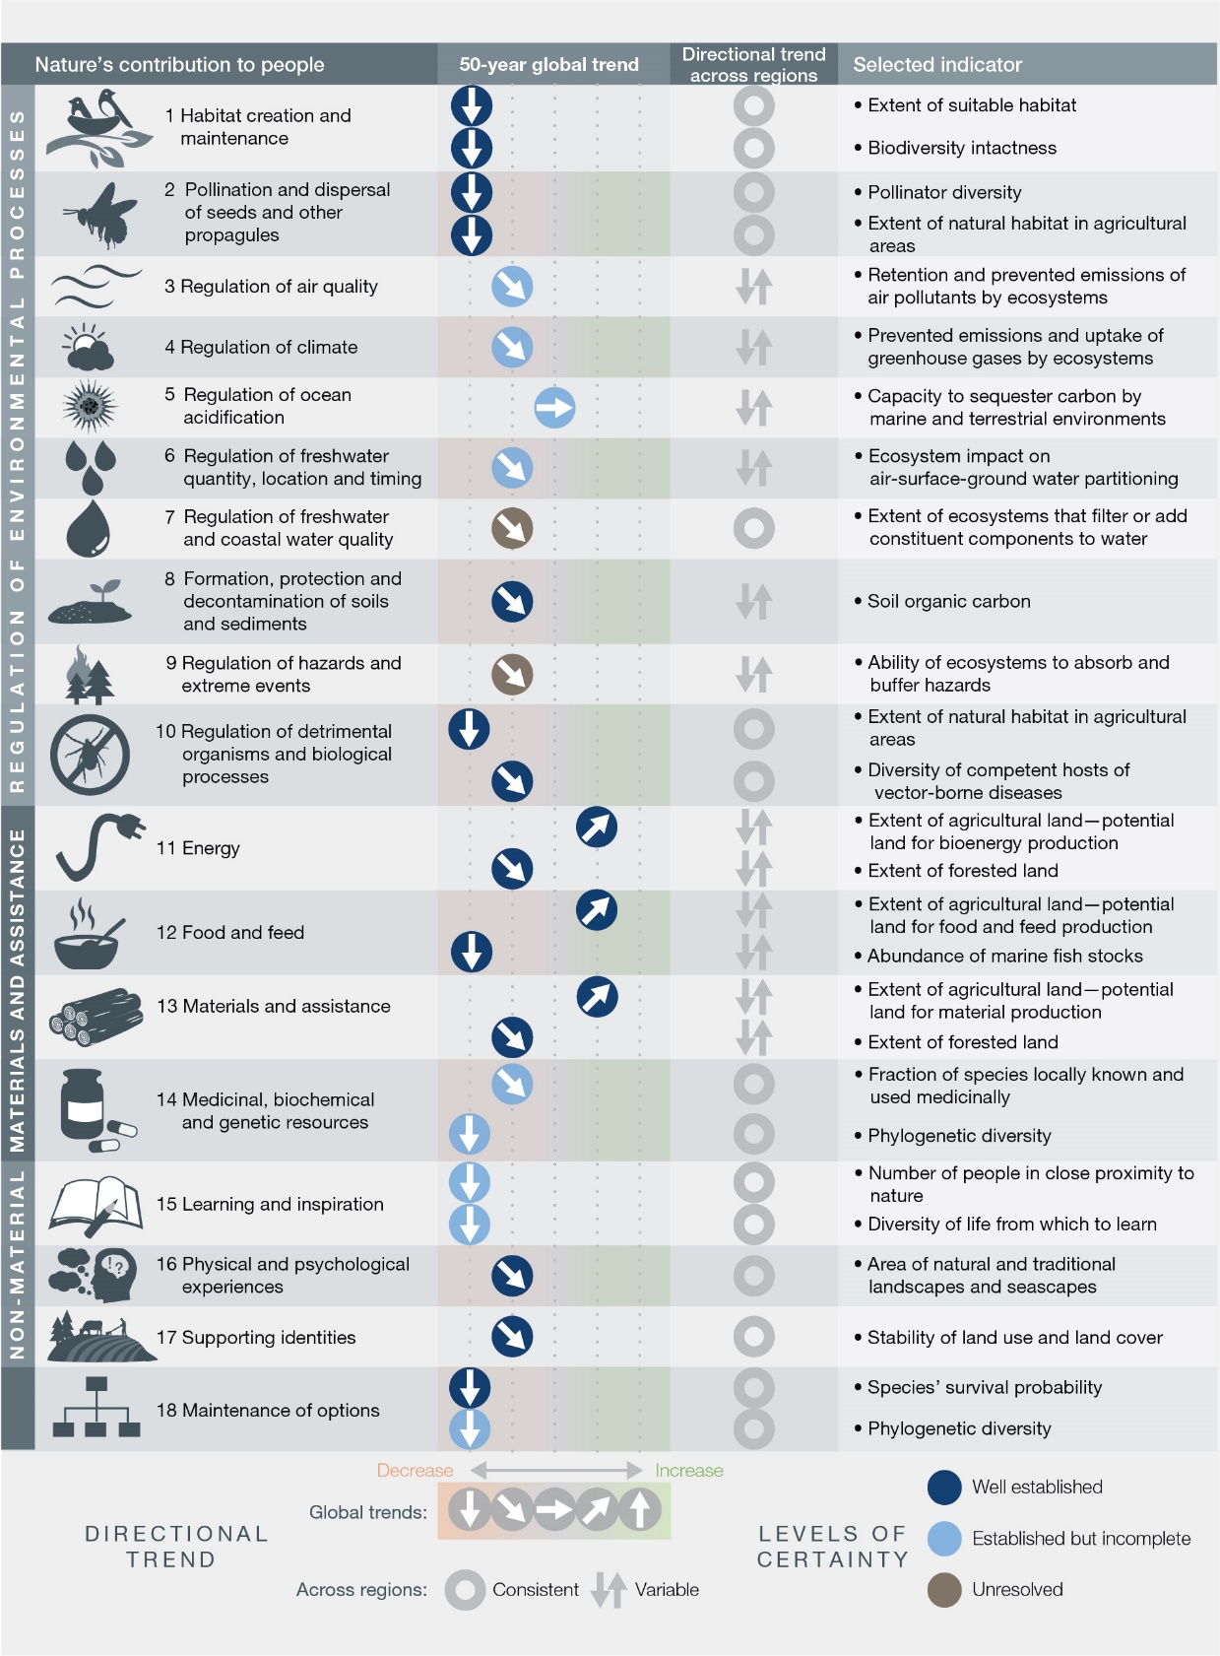
Figure 1. Global trends in the capacity of nature to sustain contributions to good quality of life from 1970 to the present, which show a decline for 14 of the 18 categories of nature’s contributions to people analysed. Data supporting global trends and regional variations come from a systematic review of over 2,000 studies {2.3.5.1}. Indicators were selected on the basis of availability of global data, prior use in assessments and alignment with 18 categories. For many categories of nature’s contributions, two indicators are included that show different aspects of nature’s capacity to contribute to human well-being within that category. Indicators are defined so that an increase in the indicator is associated with an improvement in nature’s contributions.
2. Many of nature’s contributions to people are essential for human health (well established) and their decline thus threatens a good quality of life (established but incomplete) {2.3.4}. Nature provides a broad diversity of nutritious foods, medicines and clean water (well established) {2.3.5.2, 3.3.2.1, 3.3.2.2 (Sustainable Development Goal 3)}; can help to regulate disease and the immune system {2.3.4.2}; can reduce levels of certain air pollutants (established but incomplete) {2.3.4.2, 3.3.2.2}; and can improve mental and physical health through exposure to natural areas (inconclusive), among other contributions {2.3.2.2, 2.3.4.2, 3.3.2.2 (Sustainable Development Goal 3)}. Nature is the origin of most infectious diseases (negative impact), but also the source of medicines and antibiotics for treatment (positive contribution) (well established). Zoonotic diseases are significant threats to human health, with vector-borne diseases accounting for approximately 17 per cent of all infectious diseases and causing an estimated 700,000 deaths globally per annum (established but incomplete) {3.3.2.2}. Emerging infectious diseases in wildlife, domestic animals, plants or people can be exacerbated by human activities such as land clearing and habitat fragmentation (established but incomplete) or the overuse of antibiotics driving rapid evolution of antibiotic resistance in many bacterial pathogens (well established) {3.3.2.2}. The deterioration of nature and consequent disruption of benefits to people has both direct and indirect implications for public health (well established) {2.3.5.2} and can exacerbate existing inequalities in access to health care or healthy diets (established but incomplete) {2.3.4.2}. Shifting diets towards a diversity of foods, including fish, fruit, nuts and vegetables, significantly reduces the risk of certain preventable non-communicable diseases, which are currently responsible for 20 per cent of premature mortality globally (well established) {2.3.4.2, 2.3.5.2 (NCP 2 and 12)}.
3. Most of nature’s contributions are not fully replaceable, yet some contributions of nature are irreplaceable (well established). Loss of diversity, such as phylogenetic and functional diversity, can permanently reduce future options, such as wild species that might be domesticated as new crops and be used for genetic improvement {2.3.5.3}. People have created substitutes for some other contributions of nature, but many of them are imperfect or financially prohibitive {2.3.2.2}. For example, high-quality drinking water can be realized either through ecosystems that filter pollutants or through human-engineered water treatment facilities {2.3.5.3}. Similarly, coastal flooding from storm surges can be reduced either by coastal mangroves or by dikes and sea walls {2.3.5.3}. In both cases, however, built infrastructure can be extremely expensive, incur high future costs and fail to provide synergistic benefits such as nursery habitats for edible fish or recreational opportunities {2.3.5.2}. More generally, human-made replacements often do not provide the full range of benefits provided by nature {2.3.2.2} (Figure SPM.1).
4. Humanity is a dominant global influence on life on earth, and has caused natural terrestrial, freshwater and marine ecosystems to decline (well established) {2.2.5.2} (Figure SPM.2). Global indicators of ecosystem extent and condition have shown a decrease by an average of 47 per cent of their estimated natural baselines, with many continuing to decline by at least 4 per cent per decade (established but incomplete) {2.2.5.2.1}. On land, particularly sensitive ecosystems include old-growth forests, insular ecosystems, and wetlands; and only around 25 per cent of land is sufficiently unimpacted that ecological and evolutionary processes still operate with minimal human intervention (established but incomplete) {2.2.3.4.1, 2.2.5.2.1}. In terrestrial “hotspots” of endemic species, natural habitats have generally undergone greater reductions to date in extent and condition, and tend to be experiencing more rapid ongoing decline, on average than other terrestrial regions {2.2.5.2.1}. Globally, the net rate of forest loss has halved since the 1990s, largely because of net increases in temperate and high latitude forests; high-biodiversity tropical forests continue to dwindle, and global forest area is now approximately 68 per cent of the estimated pre-industrial level (established but incomplete) {2.2.5.2.1}. Forests and natural mosaics sufficiently undamaged to be classed as “intact” (defined as being larger than 500 km² where satellites can detect no human pressure) were reduced by 7 per cent (919, 000 km2) between 2000 and 2013, shrinking in both developed and developing countries {2.2.5.2.1}. Inland waters and freshwater ecosystems show among the highest rates of decline. Only 13 per cent of the wetland present in 1700 remained by 2000; recent losses have been even more rapid (0.8 per cent per year from 1970 to 2008) (established but incomplete) {2.2.7.9}.
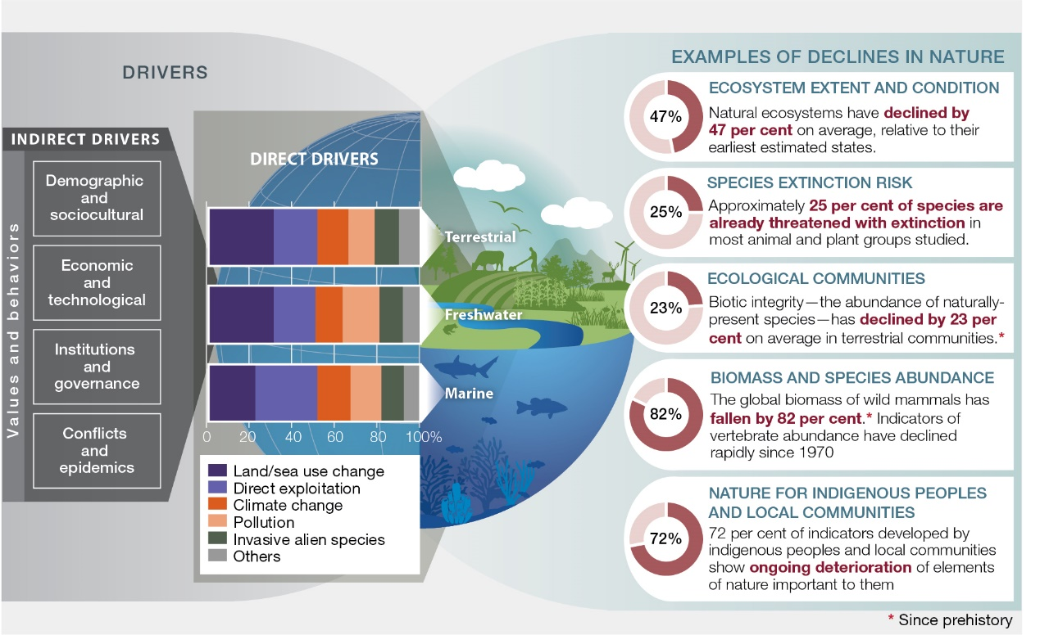
Figure 2. Examples of global declines in nature, emphasizing declines in biodiversity, that have been and are being caused by direct and indirect drivers of change. The direct drivers (land-/sea-use change; direct exploitation of organisms; climate change; pollution; and invasive alien species) result from an array of underlying societal causes. These causes can be demographic (e.g., human population dynamics), sociocultural (e.g., consumption patterns), economic (e.g., trade), technological, or relating to institutions, governance, conflicts and epidemics. They are called indirect drivers and are underpinned by societal values and behaviours. The colour bands represent the relative global impact of direct drivers, from top to bottom, on terrestrial, freshwater and marine nature, as estimated from a global systematic review of studies published since 2005. Land- and sea-use change and direct exploitation account for more than 50 per cent of the global impact on land, in fresh water and in the sea, but each driver is dominant in certain contexts {2.2.6}. The circles illustrate the magnitude of the negative human impacts on a diverse selection of aspects of nature over a range of different time scales based on a global synthesis of indicators {2.2.5, 2.2.7}.
5. Marine ecosystems, from coastal to deep sea, now show the influence of human actions, with coastal marine ecosystems showing both large historical losses of extent and condition as well as rapid ongoing declines (established but incomplete) {2.2.5.2.1, 2.2.7.15} (Figure SPM.2). Over 40 per cent of ocean area was strongly affected by multiple drivers in 2008, and 66 per cent was experiencing increasing cumulative impacts in 2014. Only 3 per cent of the ocean was described as free from human pressure in 2014 (established but incomplete) {2.2.5.2.1, 3.2.1}. Seagrass meadows decreased in extent by over 10 per cent per decade from 1970 to 2000 (established but incomplete) {2.2.5.2.1}. Live coral cover on reefs has nearly halved in the past 150 years, the decline dramatically accelerating over the past two or three decades due to increased water temperature and ocean acidification interacting with and further exacerbating other drivers of loss (well established) {2.2.5.2.1}. These coastal marine ecosystems are among the most productive systems globally, and their loss and deterioration reduce their ability to protect shorelines, and the people and species that live there, from storms, as well as their ability to provide sustainable livelihoods (well established) {2.2.5.2.1, 2.3.5.2}. Severe impacts to ocean ecosystems are illustrated by 33 per cent of fish stocks being classified as overexploited and greater than 55 per cent of ocean area being subject to industrial fishing (established but incomplete) {2.1.11.1; 2.2.5.2.4, 2.2.7.16}.
6. The global rate of species extinction is already at least tens to hundreds of times higher than the average rate over the past 10 million years and is accelerating (established but incomplete) {2.2.5.2.4} (Figure SPM.3). Human actions have already driven at least 680 vertebrate species to extinction since 1500, including the Pinta Giant Tortoise in the Galapagos in 2012, even though successful conservation efforts have saved from extinction at least 26 bird species and 6 ungulate species, including the Arabian Oryx and Przewalski’s Horse {3.2.1}. The threat of extinction is also accelerating: in the best-studied taxonomic groups, most of the total extinction risk to species is estimated to have arisen in the past 40 years (established but incomplete) {2.2.5.2.4}. The proportion of species currently threatened with extinction according to the International Union for the Conservation of Nature’s Red List criteria averages around 25 per cent across the many terrestrial, freshwater and marine vertebrate, invertebrate and plant groups that have been studied in sufficient detail to support a robust overall estimate (established but incomplete) {2.2.5.2.4, 3.2}. More than 40 per cent of amphibian species, almost a third of reef-forming corals, sharks and shark relatives and over a third of marine mammals are currently threatened {2.2.5.2.4, 3}. The proportion of insect species threatened with extinction is a key uncertainty, but available evidence supports a tentative estimate of 10 per cent (established but incomplete) {2.2.5.2.4}. Those proportions suggest that, of an estimated 8 million animal and plant species (75 per cent of which are insects), around 1 million are threatened with extinction (established but incomplete) {2.2.5.2.4}. A similar picture also emerges from an entirely separate line of evidence. Habitat loss and deterioration, largely caused by human actions, have reduced global terrestrial habitat integrity by 30 per cent relative to an unimpacted baseline; combining that with the longstanding relationship between habitat area and species numbers suggests that around 9 per cent of the world’s estimated 5.9 million terrestrial species – more than 500,000 species – have insufficient habitat for long-term survival, and are committed to extinction, many within decades, unless their habitats are restored (established but incomplete){2.2.5.2.4}. Population declines often give warning that a species’ risk of extinction is increasing. The Living Planet Index, which synthesises trends in vertebrate populations, shows that species have declined rapidly since 1970, with reductions of 40 per cent for terrestrial species, 84 per cent for freshwater species and 35 per cent for marine species (established but incomplete) {2.2.5.2.4}. Local declines of insect populations such as wild bees and butterflies have often been reported, and insect abundance has declined very rapidly in some places even without large-scale land-use change, but the global extent of such declines is not known (established but incomplete) {2.2.5.2.4}. On land, wild species that are endemic (narrowly distributed) have typically seen larger-than-average changes to their habitats and shown faster-than-average declines (established but incomplete) {2.2.5.2.3, 2.2.5.2.4}.
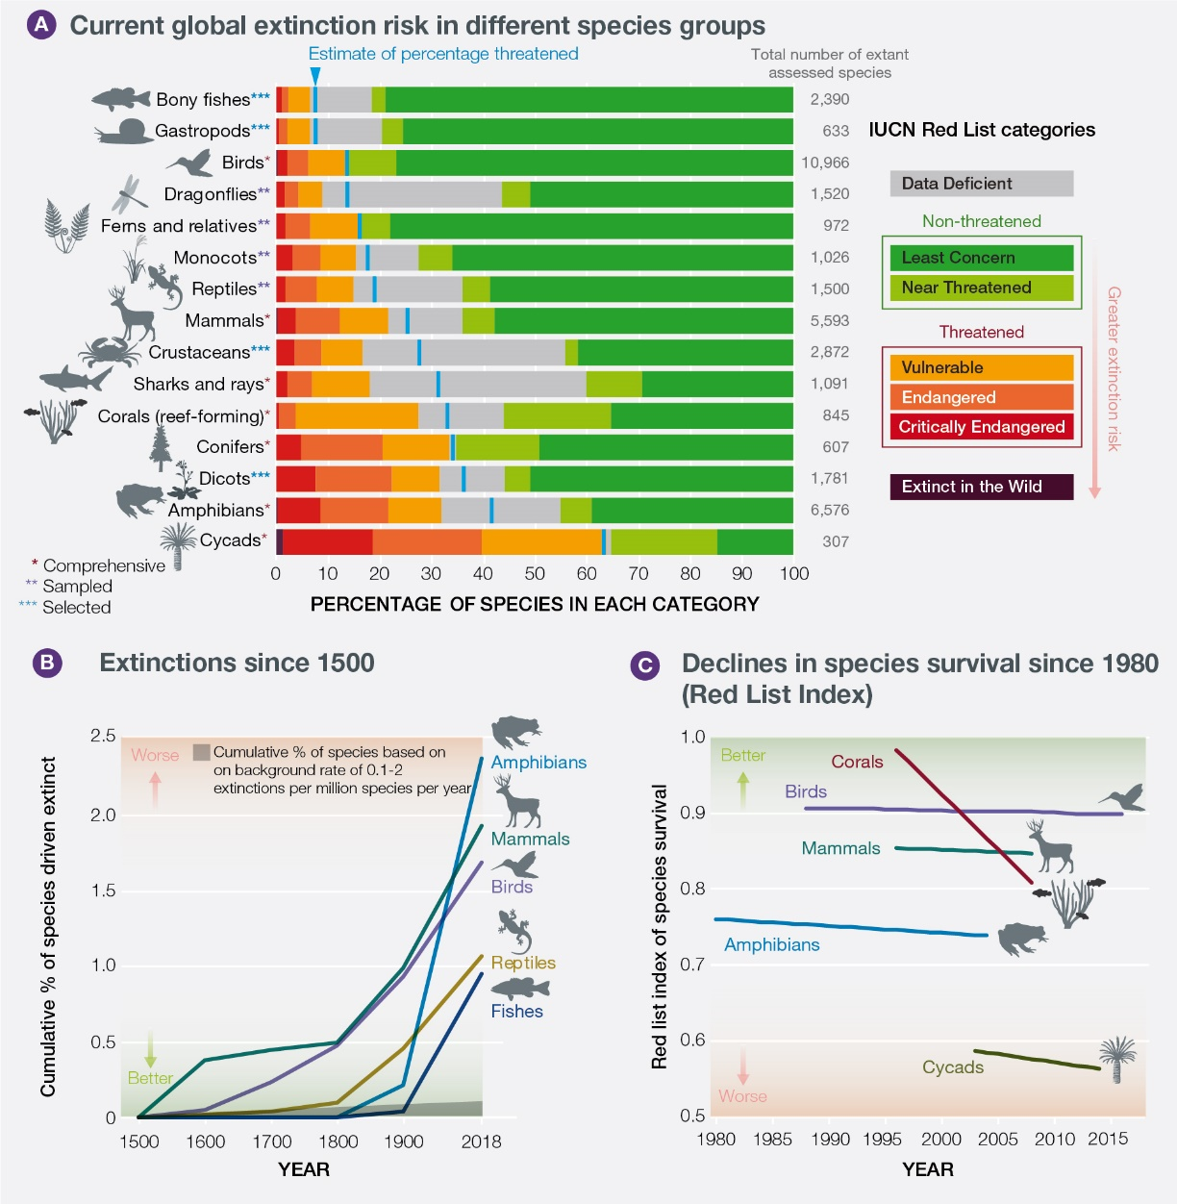
Figure 3. A substantial proportion of assessed species are threatened with extinction and overall trends are deteriorating, with extinction rates increasing sharply in the past century. (A) Percentage of species threatened with extinction in taxonomic groups that have been assessed comprehensively, or through a ‘sampled’ approach, or for which selected subsets have been assessed, by the International Union for Conservation of Nature (IUCN) Red List of Threatened Species. Groups are ordered according to the best estimate for the percentage of extant species considered threatened (shown by the vertical blue lines), assuming that data deficient species are as threatened as non-data deficient species. (B) Extinctions since 1500 for vertebrate groups. Rates for reptiles and fishes have not been assessed for all species. (C) Red List Index of species survival for taxonomic groups that have been assessed for the IUCN Red List at least twice. A value of 1 is equivalent to all species being categorized as Least Concern; a value of zero is equivalent to all species being classified as Extinct. Data for all panels derive from www.iucnredlist.org (see Chapter 3 Figure 3.4 and Chapter 2 Figure 2.7).
7. The number of local varieties and breeds of domesticated plants and animals and their wild relatives has been reduced sharply as a result of land use change, knowledge loss, market preferences and large-scale trade (well established) {2.2.5.2.6, 2.2.5.3.1}. Domestic varieties of plants and animals are the result of natural and human-managed selection, sometimes over centuries or millennia, and tend to show a high degree of adaptation (genotypic and phenotypic) to local conditions (well established) {2.2.4.4}. As a result, the pool of genetic variation which underpins food security has declined (well established) {2.2.5.2.6}. Ten per cent of domesticated breeds of mammals were recorded as extinct, as well as some 3.5 per cent of domesticated breeds of birds (well established) {2.2.5.2.6} Many hotspots of agrobiodiversity and crop wild relatives are also under threat or not formally protected. The conservation status of wild relatives of domesticated livestock has also deteriorated. These wild relatives represent critical reservoirs of genes and traits that may provide resilience against future climate change, pests and pathogens and may improve current heavily depleted gene pools of many crops and domestic animals {2.2.3.4.3}. The lands of indigenous peoples and local communities, including farmers, pastoralists and herders, are often important areas for in situ conservation of the remaining varieties and breeds (well established) {2.2.5.3.1}. Available data suggest that genetic diversity within wild species globally has been declining by about 1 per cent per decade since the mid-19th century; and genetic diversity within wild mammals and amphibians tends to be lower in areas where human influence is greater (established but incomplete) {2.2.5.2.6}.
8. Human-driven changes in species diversity within local ecological communities vary widely, depending on the net balance between species loss and the influx of alien species, disturbance-tolerant species, other human-adapted species or climate migrant species (well established) {2.2.5.2.3}. Even though human-dominated landscapes are sometimes species-rich, their species composition is markedly altered from that in natural landscapes (well established) {2.2.5.2.3, 2.2.7.10, 2.2.7.11}. As a result of human-caused changes in community composition, naturally occurring species in local terrestrial ecosystems worldwide are estimated to have lost at least 20 per cent of their original abundance on average, with hotspots of endemic species tending to have lost even more (established but incomplete) {2.2.5.2.3}. The traits of species influence whether they persist or even thrive in human-modified ecosystems (well established) {2.2.3.6, 2.2.5.2.5}. For example, species that are large, grow slowly, are habitat specialists or are carnivores – such as great apes, tropical hardwood trees, sharks and big cats – are disappearing from many areas. Many other species, including those with opposite characteristics, are becoming more abundant locally and are spreading quickly around the world; across a set of 21 countries with detailed records, the numbers of invasive alien species per country have risen by some 70 per cent since 1970 {2.2.5.2.3}. The effects of invasive alien species are often particularly severe for the native species and assemblages on islands and in other settings with high proportions of endemic species (well established) {2.2.3.4.1, 2.2.5.2.3}. Invasive alien species can have devastating effects on mainland assemblages as well: for example, a single invasive pathogen species, Batrachochytrium dendrobatidis, is a threat to nearly 400 amphibian species worldwide and has already caused a number of extinctions (well established) {2.2.5.2.3}. Many drivers add already widespread species to ecological communities in many places; and many drivers cause endemic species to decline in many places. These two processes have contributed to the widespread erosion of differences between ecological communities in different places, a phenomenon known as biotic homogenization or the “anthropogenic blender” (well established) {2.2.5.2.3}. The consequences of all these changes for ecosystem processes and hence nature’s contributions to people can be very significant. For example, the decline and disappearance of large herbivores and predators has dramatically affected the structure, fire regimes, seed dispersal, land surface albedo and nutrient availability within many ecosystems (well established) {2.2.5.2.1}. However, the consequences of changes often depend on details of the ecosystem, remain hard to predict and are still understudied (established but incomplete) {2.2.5.2.3}.
9. Many organisms show ongoing biological evolution so rapid that it is detectable within only a few years or even more quickly – in response to anthropogenic drivers (well established) {2.2.5.2.5, 2.2.5.2.6}. Management decisions that take those evolutionary changes into account will be noticeably more effective (established but incomplete) {Box 2.5}. This human-driven contemporary evolution, which has long been recognized in microbes, viruses, agricultural insect pests and weeds (well established), is now being observed in some species within all major taxonomic groups (animals, plants, fungi and microorganisms). Such changes are known to occur in response to human activities or drivers, such as hunting, fishing, harvesting, climate change, ocean acidification, soil and water pollution, invasive species, pathogens, pesticides and urbanization (established but incomplete) {2.2.5.2.5}. However, management strategies typically assume that evolutionary changes occur only over much longer time periods and thus ignore rapid evolution. These policy considerations span many spheres in which management actions designed to slow or speed evolution can dramatically change outcomes, as the following examples indicate. Insects, weeds and pathogens evolve resistance to insecticides, herbicides and other control agents, yet management strategies such as refuges, crop rotation, and crop diversity can dramatically slow that undesirable evolution (well established) {Box 2.5}. Commercial fish populations have evolved to mature earlier under intensive harvesting, which sometimes can be minimized by mandating changes in fishing gear or fish size limits (established but incomplete) {2.2.5.2.5}. Climate change favours the evolution of seasonally earlier reproduction in many organisms, which can in principle be facilitated through the introduction of individuals from populations already adapted to such conditions (established but incomplete) {2.2.5.2.5}. Mosquitoes rapidly evolve resistance to efforts to control them, but evolutionarily informed management actions can dramatically slow that undesirable evolution (established but incomplete) {2.2.5.2.5}. Contemporary evolution is thus relevant to many policy concerns. Understanding and working with contemporary evolution can address important concerns surrounding pollination and dispersal, coral persistence in the face of ocean acidification, water quality, pest regulation, food production and options for the future (established but incomplete). The specific actions taken will typically be case-specific and therefore will require careful assessment of evolutionary potential and consequences. In many cases, the best strategy could be to simply maintain the ability of natural populations to respond evolutionarily on their own - rather than through direct human manipulation of evolution.
B. Direct and indirect drivers of change have accelerated during the past 50 years
10. Today, humans extract more from the Earth and produce more waste than ever before (well established). Globally, land-use change is the direct driver with the largest relative impact on terrestrial and freshwater ecosystems, while direct exploitation of fish and seafood has the largest relative impact in the oceans (well established) (Figure SPM.2) {2.2.6.2}. Climate change, pollution and invasive alien species have had a lower relative impact to date but are accelerating (established but incomplete) {2.2.6.2, 3.2, 4.2}. Although the pace of agricultural expansion into intact ecosystems {2.1.13} has varied from country to country, losses of intact ecosystems have occurred primarily in the tropics, home to the highest levels of biodiversity on the planet (for example, 100 million hectares of tropical forest from 1980 to 2000), due to cattle ranching in Latin America (~42 million ha) and plantations in South-East Asia (~7.5 million hectares, 80 per cent in oil palm) among others {2.1.13}, noting that plantations can also increase total forest area. Within land-use change, urban areas have more than doubled since 1992. In terms of direct exploitation, approximately 60 billion tons of renewable and non-renewable resources {2.1.2} are being extracted each year. That total has nearly doubled since 1980, as population has grown considerably while the average per capita consumption of materials (e.g., plants, animals, fossil fuels, ores, construction material) has risen by 15 per cent since 1980 (established but incomplete) {2.1.6, 2.1.11, 2.1.14}. This activity has generated unprecedented impacts: since 1980, greenhouse gas emissions have doubled {2.1.11, 2.1.12}, raising average global temperatures by at least 0.7 °C {2.1.12}, while plastic pollution in oceans has increased tenfold {2.1.15}. Over 80 per cent of global wastewater is being discharged back into the environment without treatment, while 300–400 million tons of heavy metals, solvents, toxic sludge and other wastes from industrial facilities are dumped into the world’s waters each year {2.1.15}. Excessive or inappropriate application of fertilizer can lead to run-off from fields and enter freshwater and coastal ecosystems, producing more than 400 hypoxic zones that affected a total area of more than 245,000 km² as early as 2008{2.1.15}. In some island countries, invasive alien species have a significant impact on biodiversity, with introduced species being a key driver of extinctions.
11. Land-use change is driven primarily by agriculture, forestry and urbanization, all of which are associated with air, water and soil pollution. Over one third of the world’s land surface and nearly three-quarters of available freshwater resources are devoted to crop or livestock production {2.1.11}. Crop production occurs on some 12 per cent of total ice-free land. Grazing occurs on about 25 per cent of total ice-free lands and approximately 70 per cent of drylands {2.1.11}. Approximately 25 per cent of the globe’s greenhouse gas emissions come from land clearing, crop production and fertilization, with animal-based food contributing 75 per cent of that. Intensive agriculture has increased food production at the cost of regulating and non-material contributions from nature, though environmentally beneficial practices are increasing. Small landholdings (less than 2 hectares) contribute approximately 30 per cent of global crop production and 30 per cent of the global food caloric supply, using around a quarter of agricultural land and usually maintaining rich agrobiodiversity {2.1.11}. Moving to logging, between 1990 and 2015, clearing and wood harvest contributed to a total reduction of 290 million hectares in native forest cover, while the area of planted forests grew by 110 million hectares {2.1.11}. Industrial roundwood harvest is falling within some developed countries but rising on average in developing countries {2.1.11}. Illegal timber harvests and related trade supply 10–15 per cent of global timber, and up to 50 per cent in certain areas, hurting revenues for state owners and livelihoods for the rural poor. All mining on land has increased dramatically and, while still using less than 1 per cent of the Earth’s land, has had significant negative impacts on biodiversity, emissions of highly toxic pollutants, water quality and water distribution, and human health {2.1.11}. Mined products contribute more than 60 per cent of the GDP of 81 countries. There are approximately 17,000 large-scale mining sites in 171 countries, with the legal sites mostly managed by international corporations, but there is also extensive illegal and small-scale mining that is harder to trace, and both types of sites are often in locations relevant for biodiversity {2.1.11}.
12. In marine systems, fishing has had the most impact on biodiversity (target species,
non-target species and habitats) in the past 50 years alongside other significant drivers (well established) {2.1.11, 2.2.6.2} (Figure SPM.2). Global fish catches have been sustained by expanding fishing geographically and penetrating into deeper waters (well established) {3.2.1}. An increasing proportion of marine fish stocks are overfished (33 per cent in 2015), including stocks of economically important species, while 60 per cent are maximally sustainably fished and only 7 per cent are underfished (well established) {Box 3.1}. Industrial fishing, concentrated in a few countries and corporations {2.1.11}, covers at least 55 per cent of the oceans, largely concentrated in the northeast Atlantic, the northwest Pacific and upwelling regions off South America and West Africa (established but incomplete) {2.1.11}. Small-scale fisheries account for more than 90 per cent of commercial fishers (over 30 million people), and nearly half of global fish catch (established but incomplete). In 2011, illegal, unreported or unregulated fishing represented up to one third of the world’s reported catch (established but incomplete) {2.1.11}. Since 1992, regional fisheries bodies have been adopting sustainable development principles. For instance, more than 170 members of the Food and Agriculture Organization of the United Nations (FAO) adopted the Code of Conduct for Responsible Fisheries in 1995, and as of 1 April 2018, 52 countries and one member organization had become Parties to the Agreement on Port State Measures to Prevent, Deter and Eliminate Illegal, Unreported and Unregulated Fishing, in order to address the depletion of marine fisheries (established but incomplete) {2.1.11}, reduce by-catch {3, box 3.3} and lower damage to seabeds and reefs. In addition, the set of established marine protected areas has been growing (well established) {2.1.11.1, 2.2.7.16}.
13. The direct driver with the second highest relative impact on the oceans is the many changes in the uses of the sea and coastal land (well established) (Figure SPM.2) {2.2.6.2}. Coastal habitats, including estuaries and deltas critical for marine biota and regional economies, have been severely affected by sea-use changes (coastal development, offshore aquaculture, mariculture and bottom trawling) and land-use changes (onshore land clearance and urban sprawl along coastlines, plus pollution of rivers). Pollution from land sources is already a major driver of negative environmental change. Ocean mining, while relatively small, has expanded since 1981 to ~ 6,500 offshore oil and gas installations worldwide in 53 countries (60 per cent in the Gulf of Mexico by 2003) and likely will expand into the Arctic and Antarctic regions as the ice melts {2.1.11}. Ocean acidification from increased carbon dioxide levels largely affects shallow waters, with the ecosystems of the subarctic Pacific and western Arctic Ocean particularly affected. Plastic microparticles and nanoparticles are entering food webs in poorly understood ways {2.1.15.3}. Coastal waters hold the highest levels of metals and persistent organic pollutants from industrial discharge and agricultural run-off, poisoning coastal fish harvests. Severe effects from excess nutrient concentrations in certain locations include damage to fish and seabed biota. The dynamics of ocean and airborne transport of pollutants mean that the harm from inputs of plastics, persistent organic pollutants, heavy metals and ocean acidification is felt worldwide, including with consequences for human health.
14. Climate change is already having an impact on nature, from genes to ecosystems. It poses a growing risk owing to the accelerated pace of change and interactions with other direct drivers (well established) {2.1.12, 2.1.18, 2.2.6.2}. Shifts in species distribution, changes in phenology, altered population dynamics and changes in the composition of species assemblage or the structure and function of ecosystems, are evident {2.2.5.3.2, 2.2.5.2.3, 2.2.6.2} and accelerating in marine, terrestrial and freshwater systems (well established) {2.2.3.2}. Almost half (47 per cent) of threatened terrestrial mammals, excluding bats, and one quarter (23 per cent) of threatened birds may have already been negatively affected by climate change in at least part of their distribution (birds in North America and Europe suggest effects of climate change in their population trends since the 1980s) (established but incomplete) {2.2.6.2}. Ecosystems such as tundra and taiga and regions such as Greenland, previously little affected by people directly, are increasingly experiencing the impacts of climate change (well established) {2.2.7.5}. Large reductions and local extinctions of populations are widespread (well established) {2.2.6.2}. This indicates that many species are unable to cope locally with the rapid pace of climate change, through either evolutionary or behavioural processes, and that their continued existence will also depend on the extent to which they are able to disperse, to track suitable climatic conditions, and to preserve their capacity to evolve (well established) {2.2.5.2.5}. Many of these changes can have significant impacts on a number of important economic sectors, and cascading effects for other components of biodiversity. Island nations, in particular those in East Asia and the Pacific region, will be most vulnerable to sea-level rise (1m) as projected by all climate change scenarios, {2.1.1.7.1} which will displace close to 40 million people {2.1.1.7.1; 2.2.7.1.8}.
15. Unsustainable use of the Earth’s resources is underpinned by a set of demographic and economic indirect drivers that have increased, and that furthermore interact in complex ways, including through trade (well established) {2.1.6}. The global human population has increased from 3.7 to 7.6 billion since 1970 unevenly across countries and regions, which has strong implications for the degradation of nature. Per capita consumption also has grown, and also is unequal, with wide variations in lifestyles and access to resources across and within regions, plus consequences for nature that are distributed globally through trade. Total gross domestic product is four times higher and is rising faster in developed than in least developed countries. Approximately 821 million people face food insecurity in Asia and Africa, while 40 per cent of the global population lacks access to clean, safe drinking water. Generally, environmentally-based health burdens, such as air and water pollution, are more prevalent in least developed countries {2.1.2., 2.1.15}
16. Due to expansions of infrastructure, extensive areas of the planet are being opened up to new threats (well established) {2.1.11}. Globally, paved road lengths are projected to increase by 25 million kilometres by 2050, with nine tenths of all road construction occurring within least developed and developing countries. The number of dams has increased rapidly in the past 50 years. Worldwide, there are now about 50,000 large dams (higher than 15 metres) and approximately 17 million reservoirs (larger than 0.01 hectares or 100m2) {2.1.11}. The expansions of roads, cities, hydroelectric dams and oil and gas pipelines can come with high environmental and social costs, including deforestation, habitat fragmentation, biodiversity loss, land grabbing, population displacement and social disruption, including for indigenous peoples and local communities (established but incomplete). Yet infrastructure can generate positive economic effects and even environmental gains, based on efficiency, innovation, migration, and urbanization, depending on where and how investment is implemented and governed (well established) {2.1.11}. Understanding this variation in impacts is critical.
17. Long-distance transportation of goods and people, including for tourism, have grown dramatically in the past 20 years, with negative consequences for nature overall (established but incomplete). The rise in airborne and seaborne transportation of both goods and people, including a threefold increase in travel from developed and developing countries in particular, has increased pollution and significantly increased the presence of invasive alien species (well established) {2.1.15}. Between 2009 and 2013, the carbon footprint from tourism rose 40 per cent to 4.5 gigatons of carbon dioxide, and overall, 8 per cent of total greenhouse gas emissions are from tourism-related transportation and food consumption {2.1.11, 2.1.15}. The demand for nature-based tourism or ecotourism has also risen, with mixed effects on nature and local communities, including some potential for contributions to local conservation, in particular when carried out at a smaller scale {2.1.11}.
18. Distant areas of the world are increasingly connected, as consumption, production, and governance decisions increasingly influence materials, waste, energy, and information flows in other countries, generating aggregate economic gains while shifting economic and environmental costs, which can link to conflicts (established but incomplete) (Figure SPM.4).
As per capita consumption has risen, developed countries and rapidly growing developing countries {2.1.2, 2.1.6}, while at times supporting efficient production for exports, often reduce water consumption and forest degradation nationally {2.1.6, 2.1.11} by importing crops and other resources, mainly from developing countries {2.1.6}. The latter, as a result, see declines in nature and its contributions to people (habitat, climate, air and water quality) different from the exported food, fibre and timber products (Figures SPM.1 and 5). Reduced, declining and unequal access to nature’s contributions to people may, in a complex interaction with other factors, be a source of conflict within and among countries (established but incomplete). Least developed countries, often rich in and more dependent upon natural resources, have suffered the greatest land degradation, have also experienced more conflict and lower economic growth, and have contributed to environmental outmigration by several million people {2.1.2, 2.1.4}. When indigenous peoples or local communities are expelled from or threatened on their lands, including by mining or industrial logging for export, this too can spark conflict – often between actors with different levels of power, as today a few actors can control large shares of any market or capital asset rivalling those of most countries {2.1.6}, while funds channelled through tax havens support most vessels implicated in illegal, unreported and unregulated fishing. More than 2,500 conflicts over fossil fuels, water, food and land are currently occurring across the planet, and at least 1,000 environmental activists and journalists were killed between 2002 and 2013 {2.1.11, 2.1.18}.
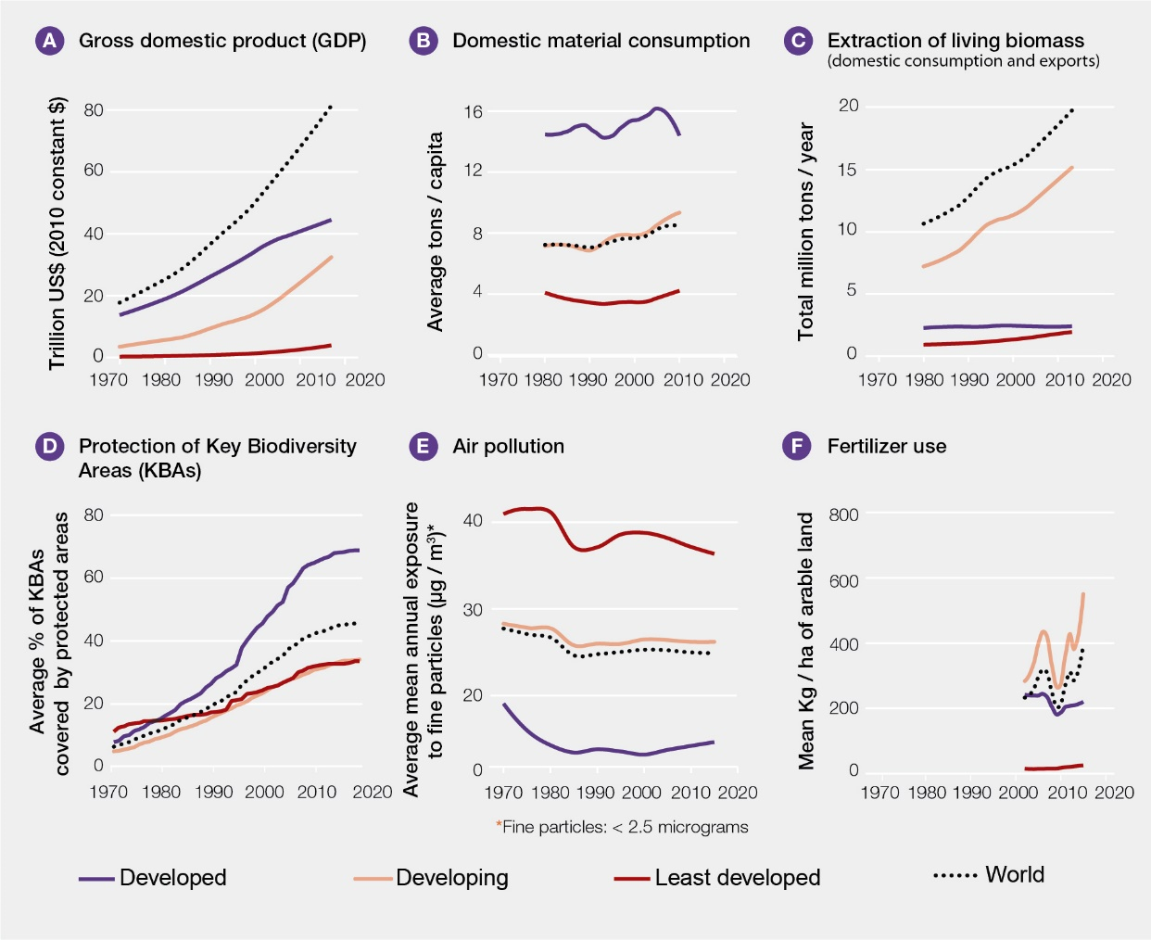
Figure 4. Development pathways since 1970 for selected key indicators of human-environment interactions, which show a large increase in the scale of global economic growth and its impacts on nature, with strong contrasts across developed, developing, and least developed countries. Countries are classified according to the United Nations World Economic Situation and Prospects (https://www.un.org/development/desa/dpad/publication/world-economic-situation-and-prospects-2019/). Global gross domestic product has risen fourfold in real terms, with the vast majority of growth occurring in developed and developing countries (A). Extraction of living biomass (e.g., crops, fish) to meet the demand for domestic consumption and for export is highest in developing countries and rising rapidly (B). However, material consumption per capita within each country (from imports and domestic production) is highest in developed countries (C). Overall protection of Key Biodiversity Areas is rising, being highest within developed countries (D). Air pollution is highest in least developed countries (E), while the challenges of non-point-source pollution from the use of fertilizers are highest in developing countries (F). Data sources: A, E, F: www.data.worldbank.org; B, C: www.materialflows.net; D: www.keybiodiversityareas.org, www.protectedplanet.net.
19. Governance has at many levels moved slowly to further and better incorporate into policies and incentives the values of nature’s contributions to people. However, around the globe, subsidies with harmful effects on nature have persisted (well established) {2.1, 3, 5, 6.4}. The incorporation by society of the value of nature’s contributions to people will entail shifts in governance even within private supply chains, for instance when civil society certifies and helps to reward desired practices, or when States block access to markets because of undesirable practices {2.1.7}. Successful local governance supported by recognition of local rights has often incorporated knowledge of how nature contributes to human wellbeing to motivate such behaviours {2.1.8}. National agencies have also promoted land management strategies that are more sustainable and introduced regulations, among other policy measures {2.1.9.2}, and have coordinated with other nations on global agreements to maintain nature’s contributions to people (2.1.10}. Economic instruments that may be harmful to nature include subsidies, financial transfers, subsidized credit, tax abatements, and prices for commodities and industrial goods that hide environmental and social costs. Such instruments favour unsustainable production and, as a consequence, can promote deforestation, overfishing, urban sprawl, and wasteful uses of water. In 2015, agricultural support potentially harmful to nature amounted to $100 billion in countries belonging to the Organization for Economic Cooperation and Development, although some subsidy reforms to reduce unsustainable pesticide uses and adjust several other consequential development practices have been introduced {2.1.9.1, 6.4.5}. Fossil fuel subsidies valued at $345 billion result in global costs of $5 trillion when including the reduction of nature’s contributions (coal accounts for about half of these costs, petroleum for about one third and natural gas for about one tenth {2.1.9.1.2}). In fisheries, subsidies to increase and maintain capacity, which in turn often lead to the degradation of nature, constitute perhaps a majority of the tens of US$ billions spent on supports {5.3.2.5}.
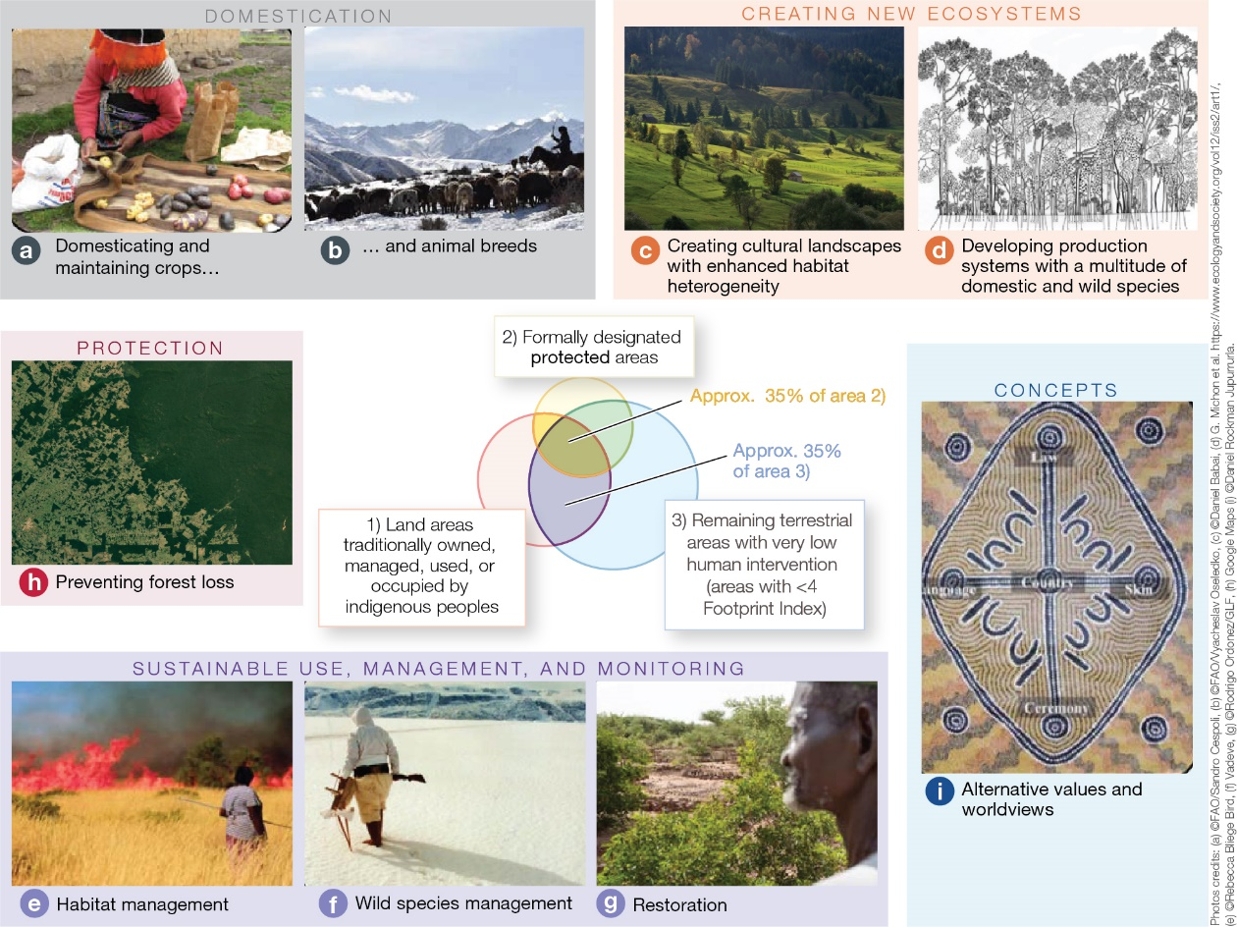
Figure 5. Contributions of indigenous peoples and local communities to the enhancement and maintenance of wild and domesticated biodiversity and landscapes. Indigenous and local knowledge systems are locally based, but regionally manifested and thus globally relevant. A wide diversity of practices actively and positively contributes to wild and domestic biodiversity through “accompanying” natural processes with anthropogenic assets (knowledge, practices and technology). Indigenous peoples often manage land and coastal areas based on culturally specific world views, applying principles and indicators such as the health of the land, caring for the country and reciprocal responsibility. As lifestyles, values and external pressures change with globalization, however, unsustainable practices are becoming increasingly common in certain regions. The image in the centre of the above figure shows the global overlap between 1) land areas traditionally owned, managed, used or occupied by indigenous peoples; 2) formally designated protected areas; and 3) remaining terrestrial areas with very low human intervention (areas that score <4 on the Human Footprint Index). Circles and overlapping sections are proportional in area. Land areas traditionally owned, managed11, used, or occupied by indigenous peoples overlap with approximately 35 per cent of the area that is formally protected, and approximately 35 per cent of all remaining terrestrial areas with very low human intervention. The topics and pictures in the figure aim to illustrate, not represent, the types and diversity of the following contributions of indigenous peoples and local communities to biodiversity: (a) domestication and maintenance of locally adapted crop and fruit varieties (potatoes, Peru) and (b) animal breeds (rider and sheep, Kyrgyzstan) {2.2.4.4}; (c) creation of species-rich habitats and high ecosystem diversity in cultural landscapes (hay meadows, Central Europe) {2.2.4.1-2}; (d) identification of useful plants and their cultivation in high-diversity ecosystems (multi-species forest garden, Indonesia) {2.2.4.3}; (e) and (f) management and monitoring of wild species, habitats and landscapes for wildlife and for increased resilience ((e) - Australia, (f) - Alaska) {2.2.4.5-6}; (g) restoration of degraded lands (Niger) {3.2.4}; (h) prevention of deforestation in recognized indigenous territories (Amazon basin, Brazil) {2.2.4.7}; (i) offering alternative concepts of relations between humanity and nature (Northern Australia).
20. Much of the world’s terrestrial wild and domesticated biodiversity lies in areas traditionally managed, owned, used or occupied by indigenous peoples and local communities (well established) (Figure SPM.5) {2.2.4}. In spite of efforts at all levels, although nature on indigenous lands is declining less rapidly than elsewhere, biodiversity and the knowledge associated with its management are still deteriorating (established but incomplete) {2.2.4, 2.2.5.3}. Despite a long history of resource use, conservation conflicts related to colonial expansion and land appropriation for parks and other uses {3.2} (well established), indigenous peoples and local communities have often managed their landscapes and seascapes in ways that were adjusted to local conditions over generations. These management methods often remain compatible with or actively support biodiversity conservation by “accompanying” natural processes with anthropogenic assets (established but incomplete) {2.2.4, 2.2.5.3.1} (Figure SPM.5). At least one quarter of the global land area is traditionally managed, owned, used or occupied by indigenous peoples. These areas include approximately 35 per cent of the area that is formally protected, and approximately 35 per cent of all remaining terrestrial areas with very low human intervention (established but incomplete) {2.2.5.3.1}. Community-based conservation institutions and local governance regimes have often been effective, at times even more effective than formally established protected areas, in preventing habitat loss (established but incomplete). Several studies have highlighted contributions by indigenous peoples and local communities in limiting deforestation, as well as initiatives showing synergies between these different mechanisms (well established) {6.3.2, 2.2.5.3}. In many regions, however, the lands of indigenous peoples are becoming islands of biological and cultural diversity surrounded by areas in which nature has further deteriorated (established but incomplete) {2.2.5.3}. Among the local indicators developed and used by indigenous peoples and local communities, 72 per cent show negative trends in nature that underpinned local livelihoods (established but incomplete) {2.2.5.3.2}. Major trends include declining availability of resources – due in part to legal and illegal territory reductions, despite expanding indigenous populations – as well as declining health and populations of culturally important species; new pests and invasive alien species as climate changes; losses in both natural forest habitats and grazing lands; and declining productivity in remnant ecosystems. A more detailed global synthesis of trends in nature observed by indigenous peoples and local communities is hindered by the lack of institutions that gather data for these locations and then synthesize them within regional and global summaries {2.2.2}.
C. Goals for conserving and sustainably using nature and achieving sustainability cannot be met by current trajectories, and goals for 2030 and beyond may only be achieved through transformative changes across economic, social, political and technological factors
21. There has been good progress towards the components of 4 of the 20 Aichi Biodiversity Targets under the Strategic Plan for Biodiversity 2011–2020. Moderate progress has been achieved towards some components of 7 more targets, but for 6 others, poor progress has been made towards all components. There is insufficient information to assess progress towards some or all components of the remaining 3 targets (established but incomplete) {3.2}. Overall, the state of nature continues to decline (12 of 16 indicators show significantly worsening trends) (well established) {3.2} (Figure SPM.6). By 2015, greater progress had been made in implementing policy responses and actions to conserve biodiversity for drivers with an impact on coral reefs and other ecosystems vulnerable to climate change (established but incomplete) {3.2}. Anthropogenic drivers of biodiversity loss, including habitat loss as a result of land-use and sea-use change (addressed by Aichi Target 5), unsustainable agriculture, aquaculture and forestry (Aichi Target 7), unsustainable fishing (Aichi Target 6), pollution (Aichi Target 8), and invasive alien species (Aichi Target 9) are increasing globally, despite national efforts to meet the Aichi Targets (established but incomplete) {3.2}.
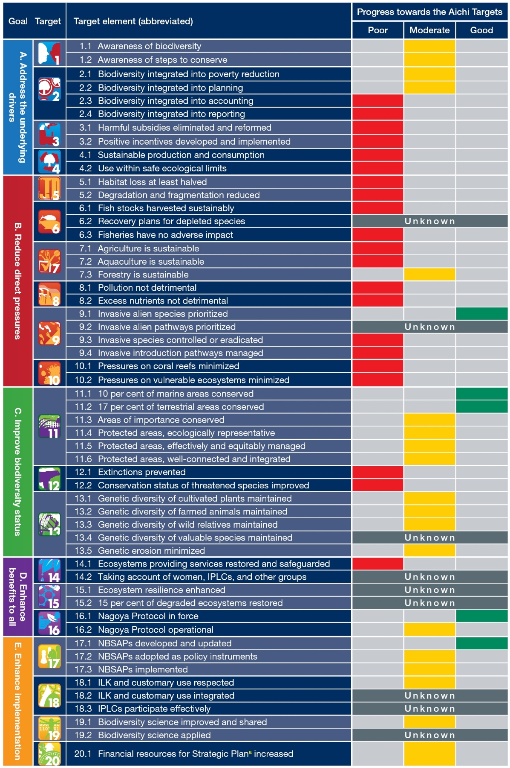
Abbreviations: ILK: indigenous and local knowledge; IPLCs: indigenous peoples and local communities;
NBSAPs: national biodiversity strategies and action plans.
ª Strategic Plan for Biodiversity 2011–2020.
Figure 6. Summary of progress towards the Aichi Targets. Scores are based on a quantitative analysis of indicators, a systematic review of the literature, the fifth National Reports to the Convention on Biological Diversity and the information available on countries’ stated intentions to implement additional actions by 2020. Progress towards target elements is scored as “Good” (substantial positive trends at a global scale relating to most aspects of the element); “Moderate” (the overall global trend is positive, but insubstantial or insufficient, or there may be substantial positive trends for some aspects of the element, but little or no progress for others; or the trends are positive in some geographic regions, but not in others); “Poor” (little or no progress towards the element or movement away from it; or, despite local, national or case-specific successes and positive trends for some aspects, the overall global trend shows little or negative progress); or “Unknown” (insufficient information to score progress).
22. Conservation actions, including protected areas, efforts to manage unsustainable use and address the illegal capture and trade of species, and the translocation and eradication of invasive species, have been successful in preventing the extinction of some species (established but incomplete). For example, conservation investment during the period between 1996 and 2008 reduced the extinction risk for mammals and birds in 109 countries by a median value of 29 per cent per country, while the rate of decrease in extinction risk for birds, mammals and amphibians would have been at least 20 per cent higher without conservation action in recent decades. Similarly, it is likely that at least 6 species of ungulate (e.g., the Arabian Oryx and Przewalski’s Horse) would now be extinct or surviving only in captivity without conservation measures. At least 107 highly threatened birds, mammals and reptiles (e.g., the Island Fox and the Seychelles Magpie-Robin) are estimated to have benefited from invasive mammal eradication on islands {3.2.2}. Although still few and spatially localized, such cases show that with prompt and appropriate action, it is possible to reduce human-induced extinction rates (established but incomplete) {2.2.5.2.4, 4}. There are, however, few other counterfactual studies assessing how trends in the state of nature or pressures upon nature would have been different in the absence of conservation efforts (well established) {3.2}.
23. Biodiversity and ecosystem functions and services directly underpin the achievement of several of the Sustainable Development Goals, including those on water and sanitation, climate action, life below water and life on land (Sustainable Development Goals 6, 13, 14 and 15), (well established) {3.3.2.1}. Nature also plays an important and complex role in the achievement of the Sustainable Development Goals related to poverty, hunger, health and well-being and sustainable cities (Sustainable Development Goals 1, 2, 3 and 11) (established but incomplete) {3.3.2.2} (Figure SPM.7). Several examples illustrate the interdependencies between nature and the Sustainable Development Goals. For example, nature and its contributions may play an important role in reducing vulnerability to climate-related extreme events and other economic, social and environmental shocks and disasters, although anthropogenic assets are also involved (established but incomplete). Nature’s underpinning of specific health targets varies across regions and ecosystems, is influenced by anthropogenic assets and remains understudied. The relationship can be positive or negative, as in the case of certain aspects of biodiversity and infectious diseases (see paragraph 2 of the present document). Nature directly underpins the livelihoods of indigenous peoples and local communities and the rural and urban poor, largely through direct consumption or through the income generated by trade in material contributions such as food (see paragraphs 2 and 36 of the present document) and energy (well established). Such contributions are generally underrepresented in poverty analyses (established but incomplete). Nature and its contributions are also relevant to the Goals for education, gender equality, reducing inequalities and promoting peace, justice and strong institutions (Sustainable Development Goals 4, 5, 10 and 16), but the current focus and wording of the related targets obscures or omits their relationship to nature (established but incomplete).
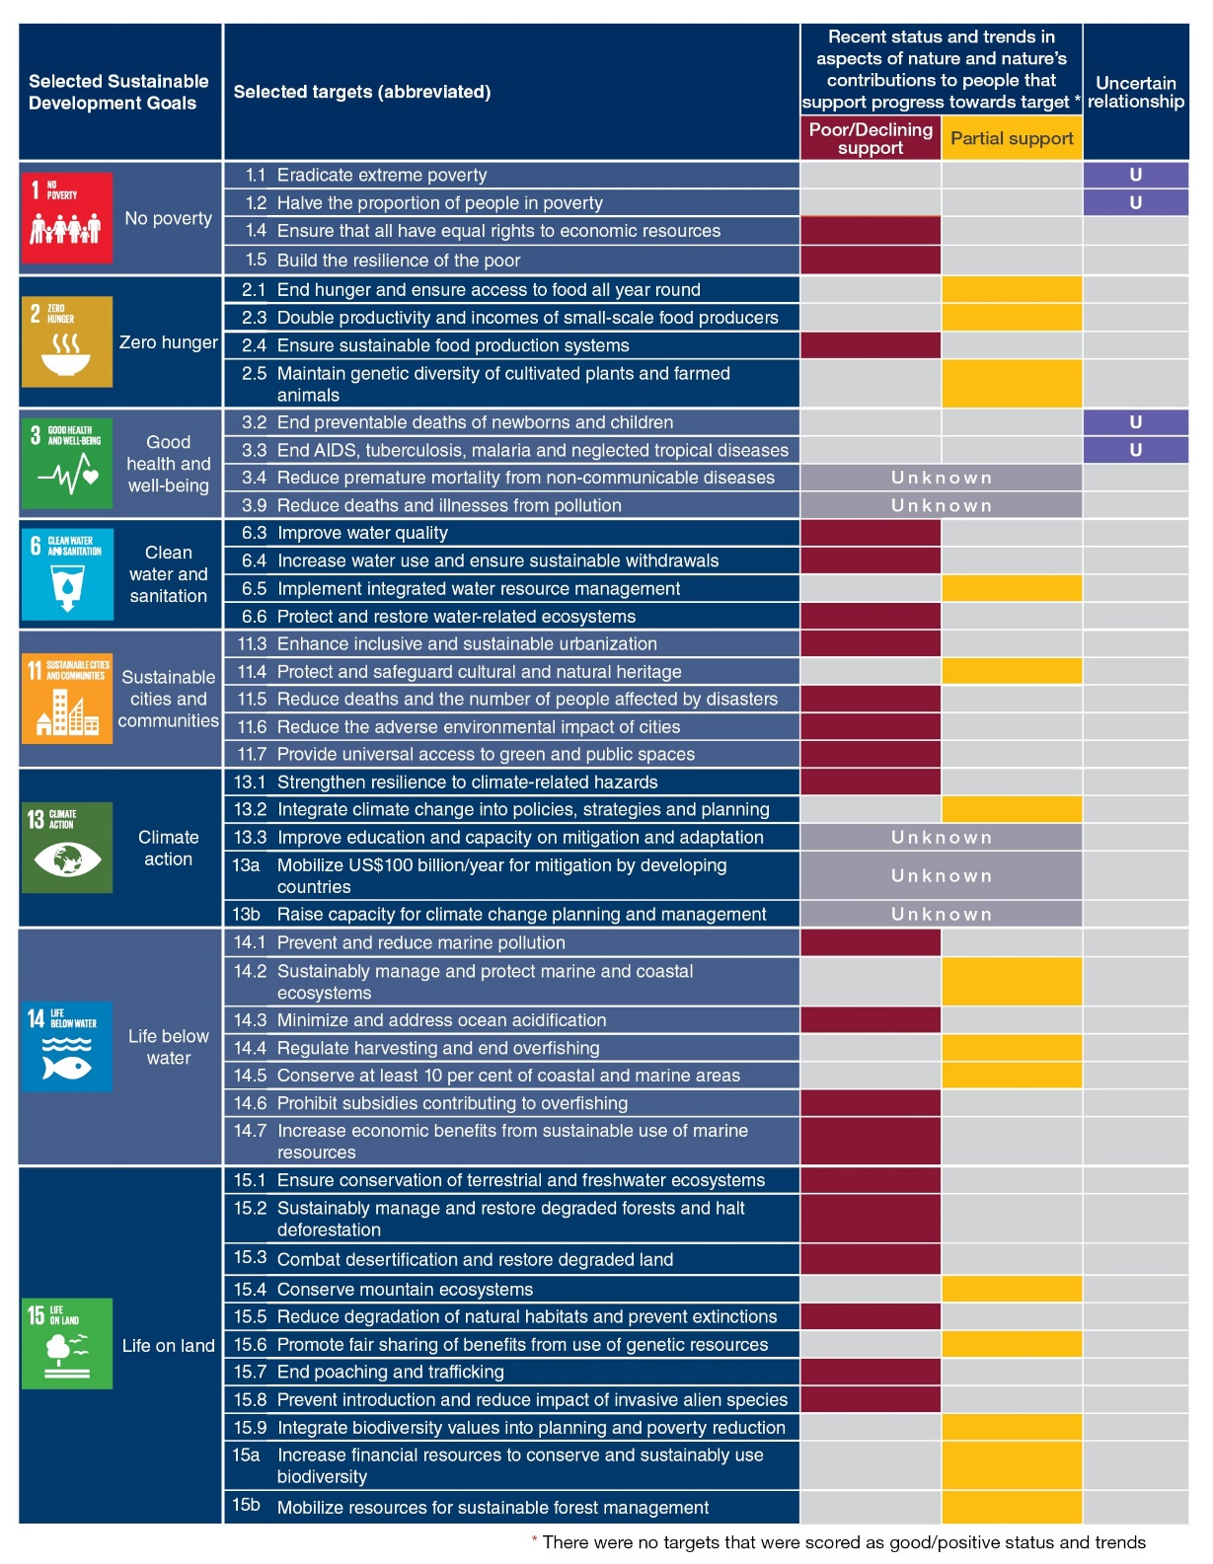
Figure 7. Summary of recent status and trends in aspects of nature and nature’s contributions to people that support progress towards achieving selected targets of the Sustainable Development Goals. The targets selected are those where the current evidence and wording of the target make it possible to assess the consequences of the trends in nature and nature’s contribution to people as they relate to the achievement of the target. Chapter 3, Section 3.3 provides an assessment of the evidence of the links between nature and the Sustainable Development Goals. The scores for the targets are based on a systematic assessment of the literature and a quantitative analysis of the indicators, where possible. None of the targets scored “Full support” (that is, having a good status or substantial positive trends on a global scale). Consequently, the score of “Full support” was not included in the table. “Partial support” means that the overall global status and trends are positive, but still insubstantial or insufficient; or there may be substantial positive trends for some relevant aspects, but negative trends for others; or the trends are positive in some geographic regions, but negative in others. “Poor/Declining support” indicates poor status or substantial negative trends at a global scale. “Uncertain relationship” means that the relationship between nature and/or nature’s contributions to people and the achievement of the target is uncertain. “Unknown” indicates that there is insufficient information to score the status and trends.
24. To achieve the Sustainable Development Goals and the 2050 Vision for Biodiversity, future targets are likely to be more effective if they take into account the impacts of climate change (well established) {3.2, 3.3}. For example, climate change is projected to greatly increase the number of species under threat, with fewer species expanding their ranges or experiencing more suitable climatic conditions than the number of species experiencing range contraction or less suitable conditions (established but incomplete) {4.2, 3.2}. The impact of climate change on the effectiveness of protected areas calls for a re-evaluation of conservation objectives; meanwhile, there are currently few protected areas whose objectives and management take climate change into account (established but incomplete). The Sustainable Development Goals for poverty, health, water and food security, and sustainability targets are closely linked through the impacts of multiple direct drivers, including climate change, on biodiversity and ecosystem functions and services, nature and nature’s contributions to people and good quality of life. In a post-2020 global biodiversity framework, placing greater emphasis on the interactions between the targets of the Sustainable Development Goals {4.6, 3.7} may provide a way forward for achieving multiple targets, as synergies (and trade-offs) can be considered. Future targets are expected to be more effective if they take into account the impacts of climate change, including on biodiversity, and action to mitigate and adapt to climate change {4.6, 3.7}.
25. The adverse impacts of climate change on biodiversity are projected to increase with increasing warming, so limiting global warming to well below 2°C would have multiple co-benefits for nature and nature’s contributions to people and quality of life; however, it is projected that some large-scale land-based mitigation measures to achieve that objective will have significant impacts on biodiversity (established but incomplete) {4.2, 4.3, 4.4, 4.5}. All climate model trajectories show that limiting human-induced climate change to well below 2°C requires immediate, rapid reductions in greenhouse gas emissions or a reliance on substantial carbon dioxide removal from the atmosphere. However, the land areas required for bioenergy crops (with or without carbon capture and storage), afforestation and reforestation to achieve the targeted carbon uptake rates are projected to be very large {4.2.4.3., 4.5.3}. The biodiversity and environmental impact of large-scale afforestation and reforestation depends to a large degree on where these occur (prior vegetation cover, state of degradation), and the tree species planted (established but incomplete). Likewise, large bioenergy crop or afforested areas are expected to compete with areas set aside for conservation, including restoration, or agriculture (established but incomplete). Consequently, large-scale land-based mitigation measures may jeopardize the achievement of other Sustainable Development Goals that depend on land resources (well established) {4.5.3}. In contrast, the benefits of avoiding and reducing deforestation and promoting restoration can be significant for biodiversity (well established) and are expected to have co-benefits for local communities (established but incomplete) {4.2.4.3}.
26. Biodiversity and nature’s regulating contributions to people are projected to decline further in most scenarios of global change over the coming decades, while the supply and demand for nature’s material contributions to people that have current market value (food, feed, timber and bioenergy) are projected to increase (well established) {4.2, 4.3} (for example, see Figure SPM.8). These changes arise from continued human population growth, increasing purchasing power, and increasing per capita consumption. The projected effects of climate change and land use change on terrestrial and freshwater biodiversity are mostly negative, increase with the degree of global warming and land use change, and have an impact on marine biodiversity through increased eutrophication and deoxygenation of coastal waters (well established) {4.2.2.3.2, 4.2.3, 4.2.4}. For instance, a synthesis of many studies estimates that the fraction of species at risk of extinction due to climate change is 5 per cent at 2°C warming, rising to 16 per cent at 4.3°C warming {4.2.1.1}. Climate change and business-as-usual fishing scenarios are expected to worsen the status of marine biodiversity (well established) {4.2.2.2, 4.2.2.3.1}. Climate change alone is projected to decrease ocean net primary production by between 3 and 10 per cent, and fish biomass by between 3 and 25 per cent (in low and high warming scenarios, respectively) by the end of the century (established but incomplete) {4.2.2.2.1}. Whether or not the current removal of nearly 30 per cent of anthropogenic carbon dioxide emissions by terrestrial ecosystems continues into the future varies greatly from one scenario to the next and depends heavily on how climate change, atmospheric carbon dioxide and land-use change interact. Important regulating contributions of nature, such as coastal and soil protection, crop pollination and carbon storage, are projected to decline (established but incomplete) {4.2.4, 4.3.2.1}. In contrast, substantial increases in food, feed, timber and bioenergy production are predicted in most scenarios (well established) {4.2.4, 4.3.2.2}. Scenarios that include substantial shifts towards sustainable management of resource exploitation and land use, market reform, globally equitable and moderate animal protein consumption, and reduction of food waste and losses result in low loss or even recovery of biodiversity (well established) {4.2.2.3.1, 4.2.4.2, 4.3.2.2, 4.5.3}.
27. The magnitude of the impacts on biodiversity and ecosystem functions and services and the differences between regions are smaller in scenarios that focus on global or regional sustainability (well established) (Figure SPM.8). Sustainability scenarios that explore moderate and equitable consumption result in substantially lower negative impacts on biodiversity and ecosystems due to food, feed and timber production (well established) {4.1.3, 4.2.4.2, 4.3.2, 4.5.3}. The general patterns at the global level – namely, declines in biodiversity and regulating contributions versus increases in the production of food, bioenergy and materials – are evident in nearly all subregions {4.2.2, 4.2.3, 4.2.4, 4.3.3}. For terrestrial systems, most studies indicate that South America, Africa and parts of Asia will be much more significantly affected than other regions, especially in scenarios that are not based on sustainability objectives (see Figure SPM.8 as an example). That is due in part to regional climate change differences and in part to the fact that scenarios generally foresee the largest land use conversions to crops or bioenergy in those regions {4.1.5, 947 4.2.4.2}. Regions such as North America and Europe are expected to have low conversion to crops and continued reforestation {4.1.5, 4.2.4.2}.
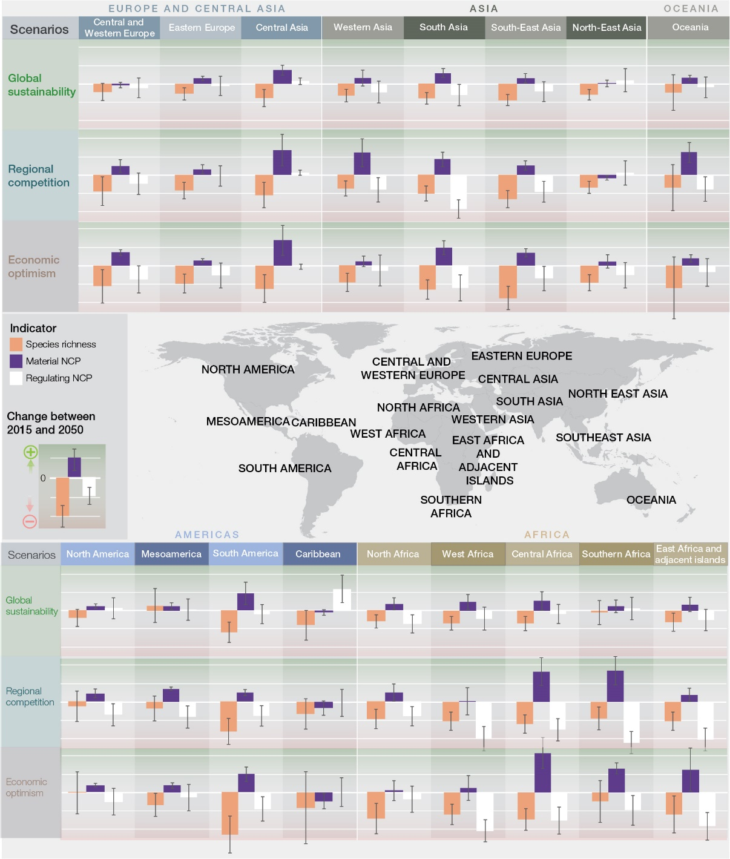
Figure 8. Projections of the impacts of land use and climate change on biodiversity and nature’s material and regulating contributions to people between 2015 and 2050. This figure illustrates three main messages: i) the impacts on biodiversity and on nature’s contributions to people (NCP) are the lowest in the “global sustainability” scenario in nearly all sub-regions, ii) regional differences in impacts are high in the regional competition and economic optimism scenario, and iii) material NCP increase the most in the regional competition and economic optimism scenarios, but this comes at the expense of biodiversity and regulating NCP. Projected impacts are based on a subset of the Shared Socioeconomic Pathway (SSP) scenarios and greenhouse gas emissions trajectories (RCP) developed in support of Intergovernmental Panel on Climate Change assessments. This figure does not cover the scenarios that include transformative change that are discussed in Chapter 5.
- The “Global sustainability” scenario combines proactive environmental policy and sustainable production and consumption with low greenhouse gas emissions (SSP1, RCP2.6; top rows in each panel);
- The “Regional competition” scenario combines strong trade and other barriers and a growing gap between rich and poor with high emissions (SSP3, RCP6.0; middle rows); and
- The “Economic optimism” scenario combines rapid economic growth and low environmental regulation with very high greenhouse emissions (SSP5, RCP8.5; bottom rows).
Multiple models were used with each of the scenarios to generate the first rigorous global-scale model comparison estimating the impact on biodiversity (change in species richness across a wide range of terrestrial plant and animal species at regional scales; orange bars), material NCP (food, feed, timber and bioenergy: purple bars) and regulating NCP (nitrogen retention, soil protection, crop pollination, crop pest control and ecosystem carbon storage and sequestration: white bars). The bars represent the normalized means of multiple models and the whiskers indicate the standard errors. The global means of percentage changes in individual indicators can be found in Figure 4.2.14.
28. Climate change impacts also play a major role in regionally-differentiated projections of biodiversity and ecosystem functioning in both marine and terrestrial systems. Novel communities, where species will co-occur in historically unknown combinations, are expected to emerge (established but incomplete) {4.2.1.2., 4.2.4.1} Substantial climate change-driven shifts of terrestrial biome boundaries, in particular in boreal, subpolar and polar regions and in (semi-)arid environments, are projected for the coming decades; a warmer, drier climate will reduce productivity in many places (well established) {4.2.4.1}. In contrast, rising atmospheric carbon dioxide concentrations can be beneficial for net primary productivity and can enhance woody vegetation cover, especially in semi-arid regions (established but incomplete) {4.2.4.1}. For marine systems, impacts are expected to be geographically variable, with many fish populations projected to move poleward due to ocean warming, meaning that local species extinctions are expected in the tropics (well established) {4.2.2.2.1}. However, that does not necessarily imply an increase in biodiversity in the polar seas, because of the rapid rate of sea ice retreat and the enhanced ocean acidification of cold waters (established but incomplete) {4.2.2.2.4}. Along coastlines, the upsurge in extreme climatic events, sea level rise and coastal development are expected to cause increased fragmentation and loss of habitats. Coral reefs are projected to undergo more frequent extreme warming events, with less recovery time in between, declining by a further 70–90 per cent at global warming of 1.5°C, and by more than 99 per cent at warming of 2°C, causing massive bleaching episodes with high coral mortality rates (well established) {4.2.2.2.2}.
D. Nature can be conserved, restored and used sustainably while simultaneously meeting other global societal goals through urgent and concerted efforts fostering transformative change
29. The Sustainable Development Goals and the 2050 Vision for Biodiversity cannot be achieved without transformative change, the conditions for which can be put in place now (well established) {2, 3, 5, 6.2} (Figure SPM.9). Increasing awareness of interconnectedness in the context of the environmental crisis and new norms regarding interactions between humans and nature would support that change (well established) {5.3, 5.4.3}. In the short term (before 2030), all decision makers could contribute to sustainability transformations, including through enhanced and improved implementation and enforcement of effective existing policy instruments and regulations, and the reform and removal of harmful existing policies and subsidies (well established). Additional measures are necessary to enable transformative change over the long term (up to 2050) to address the indirect drivers that are the root causes of the deterioration of nature (well established), including changes in social, economic and technological structures within and across nations {6.2, 6.3, 6.4, SPM Table.1}.
30. Sustainability transformations call for cross-sectoral thinking and approaches (Figure SPM.9). Sectoral policies and measures can be effective in particular contexts, but often fail to account for indirect, distant and cumulative impacts, which can have adverse effects, including the exacerbation of inequalities (well established). Cross-sectoral approaches, including landscape approaches, integrated watershed and coastal zone management, marine spatial planning, bioregional scale planning for energy, and new urban planning paradigms offer opportunities to reconcile multiple interests, values and forms of resource use, provided that these cross-sectoral approaches recognize trade-offs and uneven power relations between stakeholders (established but incomplete) {5.4.2, 5.4.3, 6.3, 6.4}.
31. Transformative change is facilitated by innovative governance approaches that incorporate existing approaches, such as integrative, inclusive, informed and adaptive governance. While such approaches have been extensively practised and studied separately, it is increasingly recognized that together, they can contribute to transformative change (established but incomplete) {6.2}. They help to address governance challenges that are common to many sectors and policy domains and create the conditions for implementing transformative change. Integrative approaches, such as mainstreaming across government sectors, are focused on the relationships between sectors and policies, and help to ensure policy coherence and effectiveness (well established). Inclusive approaches help to reflect a plurality of values and ensure equity (established but incomplete), including through equitable sharing of benefits arising from their use and rights-based approaches (established but incomplete). Informed governance entails novel strategies for knowledge production and co-production that are inclusive of diverse values and knowledge systems (established but incomplete). Adaptive approaches, including learning from experience, monitoring and feedback loops, contribute to preparing for and managing the inevitable uncertainties and complexities associated with social and environmental changes (established but incomplete) {6.2, 5.4.2}.
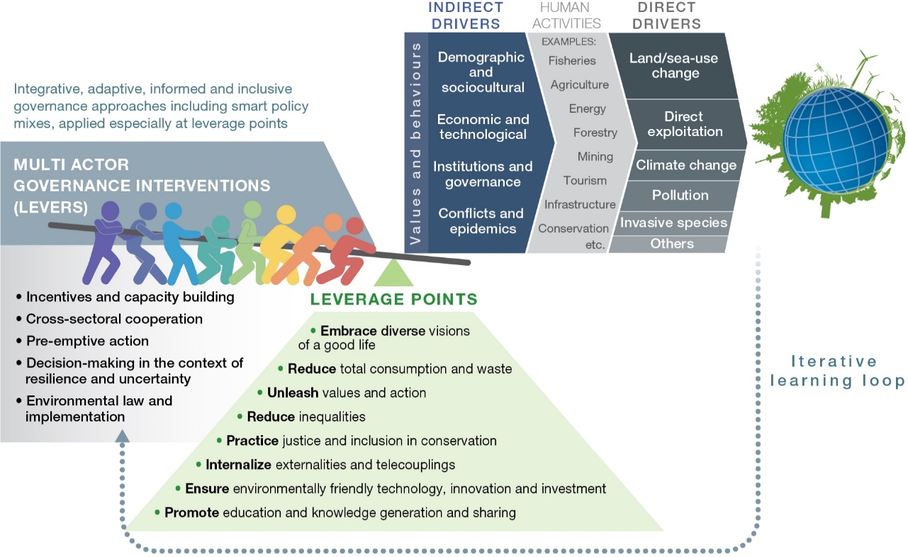
Figure 9. Transformative change in global sustainability pathways. Collaborative implementation of priority governance interventions (levers) targeting key points of intervention (leverage points) could enable transformative change from current trends towards more sustainable ones. Most levers can be applied at multiple leverage points by a range of actors, such as intergovernmental organizations, governments, non-governmental organizations, citizen and community groups, indigenous peoples and local communities, donor agencies, science and educational organizations, and the private sector, depending on the context. Implementing existing and new instruments through place-based governance interventions that are integrative, informed, inclusive and adaptive, using strategic policy mixes and learning from feedback, could enable global transformation.
32. A summary of the evidence related to the components of pathways to sustainability suggests that there are five overarching types of management interventions, or levers, and eight leverage points that are key for achieving transformative change (Figure SPM.9; D3 and D4 above) {5.4.1, 5.4.2}. The notion of levers and leverage points recognizes that complex global systems cannot be managed simply, but that in certain cases, specific interventions can be mutually reinforcing and can generate larger-scale changes towards achieving shared goals (well established) (Table SPM.1). For example, changes in laws and policies can enable and underpin changes in resource management and consumption, and in turn, changes in individual and collective behaviour and habits can facilitate the implementation of policies and laws {5.4.3}.
33. Changes towards sustainable production and consumption and towards reducing and transforming residues and waste, particularly changes in consumption among the affluent, is recognized by some individuals and communities worldwide as central to sustainable development and reducing inequalities. While actual reductions have been limited, actions already being taken at different levels can be improved, coordinated and scaled up (well established). Those include introducing and improving standards, systems and relevant regulations aimed at internalizing the external costs of production, extraction and consumption (such as pricing wasteful or polluting practices, including through penalties); promoting resource efficiency and circular and other economic models; voluntary environmental and social certification of market chains; and incentives that promote sustainable practices and innovation. Importantly, they also involve a change in the definition of what a good quality of life entails – decoupling the idea of a good and meaningful life from ever-increasing material consumption. All those approaches are more effective when they are mutually reinforcing. Actions that help to voluntarily unleash existing social values of responsibility in the form of individual, collective and organizational actions towards sustainability can have a powerful and lasting effect in shifting behaviour and cultivating stewardship as a normal social practice (established but incomplete) {5.4.1.2, 5.4.1.3, 6.4.2, 6.4.3}.
34. Expanding and effectively managing the current network of protected areas, including terrestrial, freshwater and marine areas, is important for safeguarding biodiversity (well established), particularly in the context of climate change. Conservation outcomes also depend on adaptive governance, strong societal engagement, effective and equitable benefit-sharing mechanisms, sustained funding, and monitoring and enforcement of rules (well established) {6.2, 5.4.2}. National Governments play a central role in supporting primary research, effective conservation and the sustainable use of multi-functional landscapes and seascapes. This entails planning ecologically representative networks of interconnected protected areas to cover key biodiversity areas and managing trade-offs between societal objectives that represent diverse worldviews and multiple values of nature (established but incomplete) {6.3.2.3, 6.3.3.3}. Safeguarding protected areas into the future also entails enhancing monitoring and enforcement systems, managing biodiversity-rich land and sea beyond protected areas, addressing property rights conflicts and protecting environmental legal frameworks against the pressure of powerful interest groups. In many areas, conservation depends on building capacity and enhancing stakeholder collaboration, involving non-profit groups as well as indigenous peoples and local communities to establish and manage marine protected areas and marine protected area networks, and proactively using instruments such as landscape-scale and seascape-scale participatory scenarios and spatial planning, including transboundary conservation planning (well established) {5.3.2.3, 6.3.2.3, 6.3.3.3}. Implementation beyond protected areas includes combating wildlife and timber trafficking through effective enforcement and ensuring the legality and sustainability of trade in wildlife. Such actions include prioritizing the prosecution of wildlife trafficking in criminal justice systems, using community-based social marketing to reduce demand and implementing strong measures to combat corruption at all levels (established but incomplete) {6.3.2.3}.
35. Integrated landscape governance entails a mix of policies and instruments that together ensure nature conservation, ecological restoration and sustainable use, sustainable production (including of food, materials and energy), and sustainable forest management and infrastructure planning, and that address the major drivers of biodiversity loss and nature deterioration (well established) {6.3.2, 6.3.6}. Policy mixes that are harmonized across sectors, levels of governance and jurisdictions can account for ecological and social differences across and beyond the landscape, build on existing forms of knowledge and governance and address trade-offs between tangible and
non-tangible benefits in a transparent and equitable manner (established but incomplete). Sustainable landscape management can be better achieved through multifunctional, multi-use, multi-stakeholder and community-based approaches (well established), using a combination of measures and practices, including: (a) well-managed and connected protected areas and other effective area-based conservation measures; (b) reduced impact logging, forest certification, payment for ecosystem services, among other instruments, and reduced emissions from deforestation and forest degradation; (c) support for ecological restoration; (d) effective monitoring, including public access and participation as appropriate; (e) addressing illegal activities; (f) the effective implementation of multilateral environmental agreements and other relevant international agreements by their parties; and (g) promoting sustainable, biodiversity-based food systems. (well established) {6.3.2.1, 6.3.2.3, 6.3.2, 6.3.2.4}.
36. Feeding the world in a sustainable manner, especially in the context of climate change and population growth, entails food systems that ensure adaptive capacity, minimize environmental impacts, eliminate hunger, and contribute to human health and animal welfare (established but incomplete) {5.3.2.1, 6.3.2.1}. Pathways to sustainable food systems entail
land-use planning and sustainable management of both the supply/producer and the demand/consumer sides of food systems (well established) {5.3.2.1, 6.3.2.1, 6.4}. Options for sustainable agricultural production are available and continue to be developed, with some having more impacts on biodiversity and ecosystem functions than others {6.3.2.1}. These options include integrated pest and nutrient management, organic agriculture, agroecological practices, soil and water conservation practices, conservation agriculture, agroforestry, silvopastoral systems, irrigation management, small or patch systems and practices to improve animal welfare. These practices could be enhanced through well-structured regulations, incentives and subsidies, the removal of distorting subsidies {2.3.5.2, 5.3.2.1, 5.4.2.1, 6.3.2}, and – at landscape scales – by integrated landscape planning and watershed management. Ensuring the adaptive capacity of food production entails the use of measures that conserve the diversity of genes, varieties, cultivars, breeds, landraces and species, which also contributes to diversified, healthy and culturally-relevant nutrition. Some incentives and regulations may contribute to positive changes at both the production and consumption ends of supply chains, such as the creation, improvement and implementation of voluntary standards, certification and supply-chain agreements (e.g., the Soy Moratorium) and the reduction of harmful subsidies. Regulatory mechanisms could also address the risks of co-option and lobbying, where commercial or sectoral interests may work to maintain high levels of demand, monopolies and continued use of pesticides and chemical inputs {5.3.2.1}. Non-regulatory alternatives are also important, and potentially include technical assistance – especially for small-holders – and appropriate economic incentive programs, for example, some payment for ecosystem services programmes and other
non-monetary instruments {5.4.2.1}. Options that address and engage other actors in food systems (including the public sector, civil society, consumers and grassroots movements) include participatory on-farm research, the promotion of low-impact and healthy diets and the localization of food systems. Such options could help reduce food waste, overconsumption, and the demand for animal products that are produced unsustainably, which could have synergistic benefits for human health (established but incomplete) {5.3.2.1, 6.3.2.1}.
37. Ensuring sustainable food production from the oceans while protecting biodiversity entails policy action to apply sustainable ecosystem approaches to fisheries management; spatial planning (including the implementation and expansion of marine protected areas); and more broadly, policy action to address drivers such as climate change and pollution (well established) {5.3.2.5, 6.3.3}. Scenarios show that the pathways to sustainable fisheries entail conserving, restoring and sustainably using marine ecosystems, rebuilding overfished stocks (including through targeted limits on catches or fishing efforts and moratoria), reducing pollution (including plastics), managing destructive extractive activities, eliminating harmful subsidies and illegal, unreported and unregulated fishing, adapting fisheries management to climate change impacts and reducing the environmental impact of aquaculture (well established) {4, 5.3.2.5, 6.3.3.3.2}. Marine protected areas have demonstrated success in both biodiversity conservation and improved local quality of life when managed effectively and can be further expanded through larger or more interconnected protected areas or new protected areas in currently underrepresented regions and key biodiversity areas (established but incomplete) {5.3.2.5; 6.3.3.3.1}. Due to major pressures on coasts (including from development, land reclamation and water pollution), implementing marine conservation initiatives, such as integrated coastal planning, outside of protected areas is important for biodiversity conservation and sustainable use (well established) {6.3.3.3}. Other measures to expand multi-sectoral cooperation on coastal management include corporate social responsibility measures, standards for building and construction, and eco-labelling (well established) {6.3.3.3.2, 6.3.3.3.4}. Additional tools could include both non-market and market-based economic instruments for financing conservation, including for example payment for ecosystem services, biodiversity offset schemes, blue-carbon sequestration, cap-and-trade programmes, green bonds and trust funds and new legal instruments, such as the proposed international, legally binding instrument on the conservation and sustainable use of marine biological diversity in areas beyond national jurisdiction under the United Nations Convention on the Law of the Sea (established but incomplete) {6.3.3.2, 6.3.3.1.3, 5.4.2.1, 5.4.1.7}.
38. Sustaining freshwater in the context of climate change, rising demand for water extraction and increased levels of pollution involves both cross-sectoral and sector-specific interventions that improve water-use efficiency, increase storage, reduce sources of pollution, improve water quality, minimize disruption and foster the restoration of natural habitats and flow regimes (well established) {6.3.4}. Promising interventions include practising integrated water resource management and landscape planning across scales; protecting wetland biodiversity areas; guiding and limiting the expansion of unsustainable agriculture and mining; slowing and reversing the de-vegetation of catchments; and mainstreaming practices that reduce erosion, sedimentation, and pollution run-off and minimize the negative impact of dams (well established) {6.3.4.6}.
Sector-specific interventions include improved water-use efficiency techniques (including in agriculture, mining and energy), decentralized rainwater collection (for example, household-based), integrated management of surface and groundwater (e.g., “conjunctive use”), locally-developed water conservation techniques, and water pricing and incentive programmes (such as water accounts and payment for ecosystem services programmes) {6.3.4.2, 6.3.4.4}. With regard to watershed payment for ecosystem services programmes, their effectiveness and efficiency can be enhanced by acknowledging multiple values in their design, implementation and evaluation and setting up impact evaluation systems (established but incomplete) {6.3.4.4}. Investment in infrastructure, including in green infrastructure, is important, especially in developing countries, but it can be undertaken in a way that takes into account ecological functions and the careful blending of built and natural infrastructure {5.3.2.4, 6.3.4.5}.
39. Meeting the Sustainable Development Goals in cities and making cities resilient to climate change entails solutions that are sensitive to social, economic and ecological contexts. Integrated city-specific and landscape-level planning, nature-based solutions and built infrastructure, and responsible production and consumption can all contribute to sustainable and equitable cities and make a significant contribution to the overall climate change adaptation and mitigation effort. Urban planning approaches to promote sustainability include encouraging compact communities, designing nature-sensitive road networks and creating low-impact infrastructure and transportation systems (from an emissions and land-use perspective), including active, public and shared transport {5.3.2.6, 6.3.5}. However, given that most urban growth between now and 2030 will take place in the Global South, major sustainability challenges include creatively and inclusively addressing the lack of basic infrastructure (water, sanitation and mobility), the absence of spatial planning, and the limited governance capacity and financing mechanisms. Those challenges also offer opportunities for locally-developed innovation and experimentation, which will create new economic opportunities. A combination of bottom-up and city-level efforts through public, private, community and Government partnerships, can be effective in promoting low-cost and
locally-adapted solutions to maintaining and restoring biodiversity and ecosystem functions and services. Nature-based options include combining grey and green infrastructure (such as wetland and watershed restoration and green roofs), enhancing green spaces through restoration and expansion, promoting urban gardens, maintaining and designing for ecological connectivity, and promoting accessibility for all (with benefits for human health). Additional solutions include disseminating new, low-cost technologies for decentralized wastewater treatment and energy production and creating incentives to reduce over-consumption {6.3.5}. Integrating cross-sectoral planning at the local, landscape and regional levels is important, as is involving diverse stakeholders (well established). Particularly important at the regional scale are policies and programmes that promote
sustainability-minded collective action {5.4.1.3}, protect watersheds beyond city jurisdictions and ensure the connectivity of ecosystems and habitats (e.g., through green belts). At the regional scale, cross-sectoral approaches to mitigating the impact of infrastructure and energy projects entail support for comprehensive environmental impact assessments and strategic environmental assessments of local and regional cumulative impacts {6.3.6.4, 6.3.6.6}.
40. Decision makers have a range of options and tools for improving the sustainability of economic and financial systems (well established) {6.4}. Achieving a sustainable economy involves making fundamental reforms to economic and financial systems and tackling poverty and inequality as vital parts of sustainability (well established) {6.4}. Governments could reform subsidies and taxes to support nature and its contributions to people, removing perverse incentives and instead promoting diverse instruments such as payments linked to social and environmental metrics, as appropriate (established but incomplete) {6.4.1}. At the international level, options for reacting to the challenges generated by the displacement of the impacts of unsustainable consumption and production on nature include both rethinking established instruments and developing new instruments to account for long-distance impacts. Trade agreements and derivatives markets could be reformed to promote equity and prevent the deterioration of nature, although there are uncertainties associated with implementation (established but incomplete) {6.4.4}. Alternative models and measures of economic welfare (such as inclusive wealth accounting, natural capital accounting and degrowth models) are increasingly considered as possible approaches to balancing economic growth and the conservation of nature and its contributions and to recognizing trade-offs, the pluralism of values, and long-term goals (established but incomplete) {6.4.5}. Structural changes to economies are also key to shifting action over long timescales. Such changes include technological and social innovation regimes and investment frameworks that internalize environmental impacts, such as the externalities of economic activities, including by addressing environmental impacts in socially just and appropriate ways (well established) {5.4.1.7}. Although such market-based policy instruments as payments for ecosystem services, voluntary certification and biodiversity offsetting have increased in use, their effectiveness is mixed, and they are often contested; thus, they should be carefully designed and applied to avoid perverse effects in context (established but incomplete) {5.4.2.1, 6.3.2.2, 6.3.2.5, 6.3.6.3}. The widespread internalization of environmental impacts, including externalities associated with
long-distance trade, is considered both an outcome and a component of national and global sustainable economies (well established) {5.4.1.6, 6.4}.
Table SPM.1. Approaches for sustainability and possible actions and pathways for achieving them. The appropriateness and relevance of different approaches varies according to place, system,
decision-making process and scale. The list of actions and pathways in the following table is illustrative rather than exhaustive and uses examples from the assessment report.
Approaches for sustainability | Possible actions and pathways to achieve transformative change  Key actors: (IG=intergovernmental organizations, G=Governments, NGOs =non-governmental organizations, CG=citizen and community groups, IPLC = indigenous peoples and local communities, D=donor agencies, SO= science and educational organizations, P=private sector)
Enabling integrative governance to ensure policy coherence and effectiveness | - Implementing cross-sectoral approaches that consider linkages and interconnections between sectoral policies and actions (e.g., IG, G, D, IPLC) {6.2} {D1}.  - Mainstreaming biodiversity within and across different sectors (e.g., agriculture, forestry, fisheries, mining, tourism) (e.g., IG, G, NGO, IPLC, CG, P, D) {6.2, 6.3.5.2} {D5}.  - Encouraging integrated planning and management for sustainability at the landscape and seascape levels (e.g., IG, G, D) {6.3.2} {D5}.  - Incorporating environmental and socioeconomic impacts, including externalities, into public and private decision-making (e.g., IG, G, P) {5.4.1.6} {B5}.  - Improving existing policy instruments and using them strategically and synergistically in smart policy mixes (e.g., IG, G) {6.2; 6.3.2; 6.3.3.3.1; 6.3.4.6; 6.3.5.1; 6.3.6.1} {D4}.
Promoting inclusive  governance approaches through stakeholder engagement and the inclusion of indigenous peoples and local communities to ensure equity and participation | - Recognizing and enabling the expression of different value systems and diverse interests while formulating and implementing policies and actions (e.g., IG, G, IPLCs, CG, NGO, SO, D) {6.2} {B5, D5}.  - Enabling the inclusion and participation of indigenous peoples and local communities, and women and girls in environmental governance, and recognizing and respecting the knowledge, innovations, practices, institutions and values of indigenous peoples and local communities, in accordance with national legislation (e.g., G, IPLC, P) {6.2; 6.2.4.4} {D5}.  - Facilitating national recognition for land tenure, access and resource rights in accordance with national legislation, and the application of free, prior and informed consent and fair and equitable benefit-sharing arising from their use (e.g., G, IPLC, P) {D5}.  - Improving collaboration and participation among indigenous peoples and local communities, other relevant stakeholders, policymakers and scientists to generate novel ways of conceptualizing and achieving transformative change towards sustainability (e.g., G, IG, D, IPLC, CG, SO) {D5}.
Practicing informed governance for nature and nature’s contributions to people | - Improving the documentation of nature (e.g., biodiversity inventory and other inventories) and the assessment of the multiple values of nature, including the valuation of natural capital by both private and public entities (e.g., SO, D, G, IG, P) {6.2} {D2}.  - Improving the monitoring and enforcement of existing laws and policies through better documentation and information-sharing and regular, informed and adaptive readjustments to ensure transparent and enhanced results as appropriate (e.g., IG, G, IPLC, P) {D2}.  - Advancing knowledge co-production and including and recognizing different types of knowledge, including indigenous and local knowledge and education, that enhances the legitimacy and effectiveness of environmental policies (e.g., SO, IG, G, D) {B6, D3}.
Promoting adaptive governance and management | - Enabling locally tailored choices about conservation, restoration, sustainable use and development connectivity that account for uncertainty in environmental conditions and scenarios of climate change (e.g., G, IPLC, CG, P) {D3}.  - Promoting public access to relevant information as appropriate in decision-making and responsiveness to assessments by improving monitoring, including setting goals and objectives with multiple relevant stakeholders, who often have competing interests (e.g., IG, G).  - Promoting awareness-raising activities around the principles of adaptive management, including through using short, medium and long-term goals that are regularly reassessed towards international targets (e.g., IG, G, SO, CG, D) {D4}.  - Piloting and testing well-designed policy innovations that experiment with scales and models (e.g., G, D, SO, CG, IPLC) {D4}.  - Increasing the effectiveness of current and future international biodiversity targets and goals (such as those of the post-2020 global biodiversity framework and of the Sustainable Development Goals), (e.g., IG, G, D) {6.2; 6.4}.
Managing sustainable and multifunctional landscapes and seascapes and some of the actions they may entail
Producing and consuming food sustainably | - Promoting sustainable agricultural practices, including good agricultural practices, agroecology, among others multifunctional landscape planning and cross-sectoral integrated management {6.3.2}.  - Sustainable use of genetic resources in agriculture, including by conserving gene diversity, varieties, cultivars, breeds, landraces and species (e.g., SO, IPLC, CG) {6.3.2.1} {A6}.  - Promoting the use of biodiversity-friendly management practices in crop and livestock production, forestry, fisheries and aquaculture, including, where relevant, the use of traditional management practices associated with indigenous peoples and local communities {6.3.2.1} {D6}.  - Promoting areas of natural or semi-natural habitat within and around production systems, including those that are intensively managed, and restoring or reconnecting damaged or fragmented habitats where necessary. {6.3.2.1} {D6}.  - Improving food market transparency (e.g., traceability of biodiversity impacts, transparency in supply chains) through tools such as labelling and sustainability certification.  - Improving equity in food distribution and in the localization of food systems, where appropriate and where beneficial to nature or nature’s contributions to people (NCP).  - Reducing food waste from production to consumption.  - Promoting sustainable and healthy diets {6.3.2.1} {D6}.
Integrating multiple uses for sustainable forests | - Promoting multifunctional, multi-use and multi-stakeholder approaches and improving community-based approaches to forest governance and management to achieve sustainable forest management (e.g., IG, G, CG, IPLC, D, SO, P) {6.3.2.2} {A4}.  - Supporting the reforestation and ecological restoration of degraded forest habitats with appropriate species, giving priority to native species (e.g., G, IPLC, CG, D, SO) {6.3.2.2} {A4}.  - Promoting and strengthening community-based management and governance, including customary institutions and management systems, and co-management regimes involving indigenous peoples and local communities (e.g., IG, G, CG, IPLC, D, SO, P) {6.3.2.2} {D5}.  - Reducing the negative impact of unsustainable logging by improving and implementing sustainable forest management and addressing illegal logging (e.g., IG, G, NGO, P) {6.3.2.2} {D1}.  - Increasing efficiency in forest product use, including incentives for adding value to forest products (such as sustainability labelling or public procurement policies), as well as promoting intensive production in well-managed forests so as to reduce pressures elsewhere (e.g., P, D, NGO) {6.3.2.2} {B1}.
Conserving, effectively managing and sustainably using terrestrial landscapes | - Supporting, expanding and promoting effectively managed and ecologically representative networks of well-connected protected areas and other multifunctional conservation areas, such as other effective area-based conservation measures (e.g., IG, G, IPLC, CG, D) {3.2.1, 6.3.2.3} {C1, D7}.  - Using extensive, proactive and participatory landscape-scale spatial planning to prioritize land uses that balance and further safeguard nature and to protect and manage key biodiversity areas and other important sites for present and future biodiversity (e.g., IG, G, D) {B1, D7}.  - Managing and restoring biodiversity beyond protected areas (e.g., IG, G, CG, IPLC, P, NGO, D) {B1}.  - Developing robust and inclusive decision-making processes that facilitate the positive contributions of indigenous peoples and local communities to sustainability by incorporating locally-attuned management systems and indigenous and local knowledge {B6, D5}.  - Improving and expanding the levels of financial support for conservation and sustainable use through a variety of innovative options, including through partnerships with the private sector {6.3.2.5} {D5, D7, D10}.  - Prioritizing land-based adaptation and mitigation measures that do not have negative impacts on biodiversity (e.g., reducing deforestation, restoring land and ecosystems, improving the management of agricultural systems such as soil carbon, and preventing the degradation of wetlands and peatlands) {D8}.  - Monitoring the effectiveness and impacts of protected areas and other effective area-based conservation measures.
Promoting sustainable governance and management of seascapes, oceans and marine systems | - Promoting shared and integrated ocean governance, including for biodiversity, beyond national jurisdictions (e.g., IG, G, NGO, P, SO, D) {6.3.3.2} {D7}.  - Expanding, connecting and effectively managing marine protected area networks (e.g., IG, G, IPLC, CG {5.3.2.3} {D7}, including protecting and managing priority marine key biodiversity areas and other important sites for present and future biodiversity, and increasing protection and connectivity.  - Promoting the conservation and/or restoration of marine ecosystems through rebuilding overfished stocks; preventing, deterring and eliminating illegal, unreported and unregulated fishing; encouraging ecosystem-based fisheries management; and controlling pollution through the removal of derelict gear and through addressing plastic pollution (e.g., IG, G, P, IPLC, CG, SO, D) {B1, D7}.  - Promoting ecological restoration, remediation and the multifunctionality of coastal structures, including through marine spatial planning (e.g., IG, G, NGO, P, CG, IPLC, SO, D) {6.3.3.3.1} {B1, D7}.  - Integrating ecological functionality concerns into the planning phase of coastal construction (e.g., IG, G, NGO, P, CG, IPLC, SO, D) {6.3.3.3.1} {B1, D7}.  - Expanding multi-sectoral cooperation by increasing and improving corporate social responsibility measures and regulation in building and construction standards, eco-labelling and best practices (e.g., IG, G, NGO, P, CG, IPLC, SO, D) {6.3.3.3.1} {B1, D7}.  - Encouraging effective fishery reform strategies through incentives with positive impacts on biodiversity and through the removal of environmentally harmful subsidies (e.g., IG, G) {6.3.3.2} {D7}.  - Reducing the environmental impacts of aquaculture by voluntary certification and by using best practices in fisheries and aquaculture production methods (e.g., G, IPLC, NGO, P) {6.3,3,3,5} {6.3.3.3.2} {B1, D7}.  - Reducing point and nonpoint source pollution, including by managing marine microplastic and macroplastic pollution through effective waste management, incentives and innovation (e.g., G, P, NGO) {6.3.3.3.1} {B1, D7}.  - Increasing ocean conservation funding (e.g., G, D, P) {6.3.3.1.3} {D7}.
Improving freshwater management, protection and connectivity | - Integrating water resource management and landscape planning, including through increased protection and connectivity of freshwater ecosystems, improving transboundary water cooperation and management, addressing the impacts of fragmentation caused by dams and diversions, and incorporating regional analyses of the water cycle (e.g., IG, G, IPLC, CG, NGO, D, SO, P) {6.3.4.6; 6.3.4.7} {B1}.  - Supporting inclusive water governance, e.g., through developing and implementing invasive alien species management with relevant stakeholders (e.g., IG, G, IPLC, CG, NGO, D, SO, P) {6.3.4.3} {D4}.  - Supporting co-management regimes for collaborative water management and to foster equity between water users (while maintaining a minimum ecological flow for the aquatic ecosystems), and engaging stakeholders and using transparency to minimize environmental, economic and social conflicts {D4}.  - Mainstreaming practices that reduce soil erosion, sedimentation and pollution run-off (e.g., G, CG, P) {6.3.4.1}.  - Reducing the fragmentation of freshwater policies by coordinating international, national and local regulatory frameworks (e.g., G, SO) {6.3.4.7; 6.3.4.2}.  - Increasing water storage by facilitating groundwater recharge, wetlands protection and restoration, alternative storage techniques and restrictions on groundwater abstraction. (e.g., G, CG, IPLC, P, D) {6.3.4.2} {B1, B3}.  - Promoting investment in water projects with clear sustainability criteria (e.g., G, P, D, SO) {6.3.4.5} {B1, B3}.
Building sustainable cities that address critical needs while conserving nature, restoring biodiversity, maintaining and enhancing ecosystem services | - Engaging sustainable urban planning (e.g., G, CG, IPLC, NGO, P) {6.3.5.1} {D9}.  - Encouraging densification for compact communities, including through brownfield development and other strategies {6.3.5.3}.  - Including biodiversity protection, biodiversity offsetting, river basin protection and ecological restoration in regional planning {6.3.5.1}.  - Safeguarding urban key biodiversity areas and ensuring that they do not become isolated through incompatible uses of surrounding land {6.3.5.2; SM 6.4.2}.  - Promoting biodiversity mainstreaming through stakeholder engagement and integrative planning (e.g., G, NGO, CG, IPLC) {6.3.5.3}.  - Encouraging alternative business models and incentives for urban conservation {6.3.2.1}.  - Promoting sustainable production and consumption {6.3.6.4}.  - Promoting nature-based solutions (e.g., G, NGO, SO, P) {6.3.5.2} {D8, D9}.  - Promoting, developing, safeguarding or retrofitting green and blue infrastructure for water management while improving grey (hard) infrastructure to address biodiversity outcomes {6.3.5.2}.  - Promoting ecosystem-based adaptation within communities {3.7; 5.4.2.2}.  - Maintaining and designing for ecological connectivity within urban spaces, particularly with native species {6.3.5.2; SM 6.4.1}.  - Increasing urban green spaces and improving access to them {6.3.2}.  - Increasing access to urban services for low-income communities, with priorities for sustainable water management, integrated sustainable solid waste management and sewage systems and safe and secure shelter and transport (e.g., G, NGO) {6.3.5.4} {D9}.
Promoting sustainable energy and infrastructure projects and production | - Developing sustainable strategies, voluntary standards and guidelines for sustainable renewable energy and bioenergy projects (e.g., G, SO, P) {6.3.6} {D8}.  - Strengthening and promoting biodiversity-inclusive environmental impact assessments, laws and guidelines {6.3.6.2} {B1}.  - Mitigating environmental and social impacts where possible and promoting innovative financing and restoration when necessary (e.g., G, P, NGO, D) {6.3.6.3} {B1}, including by redesigning incentive programmes and policies to promote bioenergy systems that optimize trade-offs between biodiversity loss and benefits (e.g., through life cycle analysis) {D8}.  - Supporting community-based management and decentralized sustainable energy production (e.g., G, CG, IPLC, D) {6.3.6.4} {6.3.6.5} {D9}.  - Reducing energy demands so as to reduce the demand for biodiversity-impacting infrastructure (e.g., through energy efficiency, new clean energy and reducing unsustainable consumption) (e.g., G, P) {B1}.
Improving the sustainability of economic and financial systems | - Developing and promoting incentive structures to protect biodiversity (e.g., removing harmful incentives) (e.g., IG, G) {6.4} {D10}.  - Promoting sustainable production and consumption, such as through sustainable sourcing, resource efficiency and reduced production impacts, circular and other economic models, corporate social responsibility, life-cycle assessments that include biodiversity, trade agreements and public procurement policies (e.g., G, CA, NGO, SO) {6.4.3, 6.3.2.1} {D10}.  - Exploring alternative methods of economic accounting, such as natural capital accounting and Material and Energy Flow Accounting, among others (e.g., IG, G, SO) {6.4.5} {D10}.  - Encouraging policies that combine poverty reduction with measures to increase the provision of nature’s contributions and the conservation and sustainable use of nature (e.g., IG, G, D) {3.2.1} {C2}.  - Improving market-based instruments, such as payment for ecosystem services, voluntary certification and biodiversity offsetting, to address challenges such as equity and effectiveness (e.g., G, P, NGO, IPLC, CG, SO) {B1}.  - Reducing consumption (e.g., encouraging consumer information to reduce overconsumption and waste, using public policies and regulations and internalizing environmental impacts)  (e.g., G, P, NGO) {B4, C2}.  - Creating and improving supply-chain models that reduce the impact on nature {D3}.

Appendix I
Conceptual framework and definitions
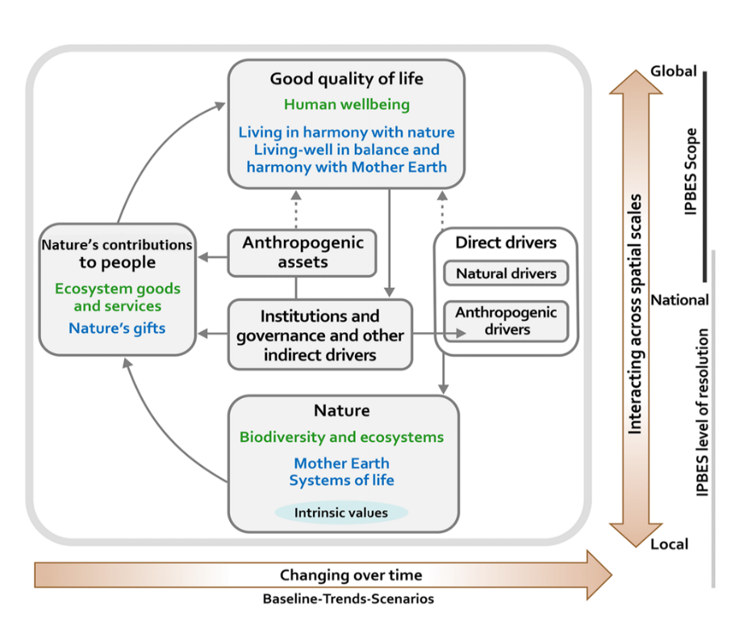
Figure 10. The IPBES Conceptual Framework is a highly simplified model of the complex interactions between the natural world and human societies. The model identifies the main elements (boxes within the main panel outlined in grey), together with their interactions (arrows in the main panel), that are most relevant to the Platform’s goal. “Nature”, “nature’s contributions to people” and “good quality of life” (indicated as black headlines and defined in each corresponding box) are inclusive categories that were identified as meaningful and relevant to all stakeholders involved in IPBES during a participatory process, including various disciplines of the natural and social sciences and the humanities, and other knowledge systems, such as those of indigenous peoples and local communities. Text in green denotes scientific concepts, and text in blue denotes concepts originating in other knowledge systems. The solid arrows in the main panel denote influence between elements, and dotted arrows denote links that are acknowledged as important, but that are not the main focus of the Platform. The thick coloured arrows below and to the right of the central panel indicate the scales of time and space, respectively. This conceptual framework was accepted by the Plenary in decision IPBES/2/4, and the Plenary took note of an update presented in IPBES/5/INF/24 and in decision IPBES/5/1. Further details and examples of the concepts defined in the box can be found in the glossary and in Chapter 1.
Nature, in the context of the Platform, refers to the natural world, with an emphasis on biodiversity. Within the context of science, it includes categories such as biodiversity, ecosystems, ecosystem functioning, evolution, the biosphere, humankind’s shared evolutionary heritage, and biocultural diversity. Within the context of other knowledge systems, it includes categories such as Mother Earth and systems of life. Other components of nature, such as deep aquifers, mineral and fossil reserves, and wind, solar, geothermal and wave power, are not the focus of the Platform. Nature contributes to societies through the provision of contributions to people.
Anthropogenic assets refers to built-up infrastructure, health facilities, knowledge (including indigenous and local knowledge systems and technical or scientific knowledge, as well as formal and non-formal education), technology (both physical objects and procedures), and financial assets, among others. Anthropogenic assets have been highlighted to emphasize that a good life is achieved by a
co-production of benefits between nature and societies.
Nature’s contributions to people refers to all the benefits that humanity obtains from nature. Ecosystem goods and services, considered separately or in bundles, are included in this category. Within other knowledge systems, nature’s gifts and similar concepts refer to the benefits of nature from which people derive good quality of life. Aspects of nature that can be negative to people (detriments), such as pests, pathogens or predators, are also included in this broad category.
Nature’s regulating contributions to people refers to functional and structural aspects of organisms and ecosystems that modify the environmental conditions experienced by people, and/or sustain and/or regulate the generation of material and non-material contributions. For example, these contributions include water purification, climate regulation and the regulation of soil erosion.
Nature’s material contributions to people refers to substances, objects or other material elements from nature that sustain people’s physical existence and the infrastructure (i.e. the basic physical and organizational structures and facilities, such as buildings, roads, power supplies) needed for the operation of a society or enterprise. They are typically physically consumed in the process of being experienced, such as when plants or animals are transformed into food, energy, or materials for shelter or ornamental purposes.
Nature’s non-material contributions to people refers to nature’s contribution to people’s subjective or psychological quality of life, individually and collectively. The entities that provide these intangible contributions can be physically consumed in the process (e.g., animals in recreational or ritual fishing or hunting) or not (e.g., individual trees or ecosystems as sources of inspiration).
Drivers of change refers to all those external factors that affect nature, anthropogenic assets, nature’s contributions to people and good quality of life. They include institutions and governance systems and other indirect drivers, and direct drivers (both natural and anthropogenic).
Institutions and governance systems and other indirect drivers are the ways in which societies organize themselves and the resulting influences on other components. They are the underlying causes of environmental change that are exogenous to the ecosystem in question. Because of their central role, influencing all aspects of human relationships with nature, they are key levers for
decision-making. “Institutions” encompasses all formal and informal interactions among stakeholders and the social structures that determine how decisions are taken and implemented, how power is exercised, and how responsibilities are distributed. To varying degrees, institutions determine the access to and control, allocation and distribution of the components of nature and of anthropogenic assets and their contributions to people. Examples of institutions are systems of property and access rights to land (e.g., public, common-pool or private), legislative arrangements, treaties, informal social norms and rules, including those emerging from indigenous and local knowledge systems, and international regimes such as agreements against stratospheric ozone depletion or for the protection of endangered species of wild fauna and flora. Economic policies, including macroeconomic, fiscal, monetary or agricultural policies, play a significant role in influencing people’s decisions and behaviour and the way in which they relate to nature in the pursuit of benefits. However, many of the drivers of human behaviour and preferences, which reflect different perspectives on a good quality of life, work largely outside the market system.
Direct drivers, both natural and anthropogenic, affect nature directly. “Natural drivers” are those that are not the result of human activities and are beyond human control. These include earthquakes, volcanic eruptions and tsunamis, extreme weather or ocean-related events such as prolonged drought or cold periods, tropical cyclones and floods, the El Niño/La Niña Southern Oscillation and extreme tidal events. The direct anthropogenic drivers are those that are the result of human decisions, namely, of institutions and governance systems and other indirect drivers. Anthropogenic drivers include habitat conversion, e.g., degradation of land and aquatic habitats, deforestation and afforestation, exploitation of wild populations, climate change, pollution of soil, water and air and species introductions. Some of these drivers, such as pollution, can have negative impacts on nature; others, as in the case of habitat restoration, or the introduction of a natural enemy to combat invasive species, can have positive effects.
Good quality of life is the achievement of a fulfilled human life, a notion which varies strongly across different societies and groups within societies. It is a context-dependent state of individuals and human groups, comprising access to food, water, energy and livelihood security, and also health, good social relationships and equity, security, cultural identity, and freedom of choice and action. From virtually all standpoints, a good quality of life is multidimensional, having material as well as immaterial and spiritual components. What a good quality of life entails, however, is highly dependent on place, time and culture, with different societies espousing different views of their relationships with nature and placing different levels of importance on collective versus individual rights, the material versus the spiritual domain, intrinsic versus instrumental values, and the present time versus the past or the future. The concept of human well-being used in many western societies and its variants, together with those of living in harmony with nature and living well in balance and harmony with Mother Earth, are examples of different perspectives on a good quality of life.

Appendix II
Communication of the degree of confidence
In this assessment, the degree of confidence in each main finding is based on the quantity and quality of evidence and the level of agreement regarding that evidence (Figure SPM.A1). The evidence includes data, theory, models and expert judgement. Further details of the approach are documented in the note by the secretariat on the information on work related to the guide on the production of assessments (IPBES/6/INF/17).
The summary terms to describe the evidence are:
- Well established: there is a comprehensive meta-analysis or other synthesis or multiple independent studies that agree.
- Established but incomplete: there is general agreement, although only a limited number of studies exist; there is no comprehensive synthesis, and/or the studies that exist address the question imprecisely.
- Unresolved: multiple independent studies exist but their conclusions do not agree.
- Inconclusive: there is limited evidence and a recognition of major knowledge gaps.
Figure SPM.A1
The four-box model for the qualitative communication of confidence.
Confidence increases towards the top-right corner as suggested by the increasing strength of shading.
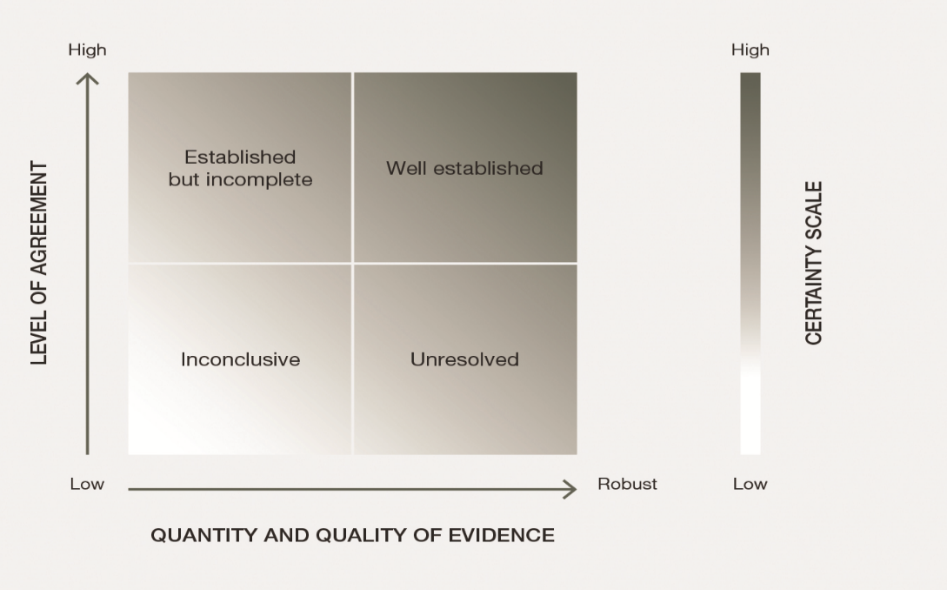
Source: IPBES, 2016.

Appendix III
Knowledge gaps
In the course of conducting this assessment key information needs were identified. See draft table Appendix IV.
- Data, inventories and monitoring on nature and the drivers of change
- Gaps on biomes and units of analysis
- Taxonomic gaps
- NCP-related gaps
- Links between nature, nature’s contributions to people and drivers with respect to targets and goals
- Integrated scenarios and modelling studies
- Potential policy approaches
- Indigenous peoples and local communities

Appendix IV
Draft table of knowledge gaps
Disclaimer: This table of knowledge gaps was prepared by the experts of the global assessment and presented to and considered by a working group established by the Plenary at its seventh session. The Plenary did not approve this table as part of the summary for policymakers. It is therefore included in draft form, which does not imply working group or Plenary approval.
Sector | Knowledge gaps (in data, indicators, inventories, scenarios)
Data, inventories and monitoring on nature and the drivers of change | - Data on ecosystem processes (including rates of change) that underpin nature’s contributions to people and ecosystem health  - Data from monitoring of ecosystem condition (generally less well represented than ecosystem extent)  - Data on changing interactions among organisms and taxa  - Impacts of increasing CO₂ upon the total Net Primary Production of marine systems, and consequences for ecosystem function and nature’s contributions to people  - Syntheses of how human impacts affect organismal traits and global patterns and trends in genetic composition  - Data on extinction risks and population trends, especially for insects, parasites and fungal and microbial species  - Indicators on the global extent and consequences of biotic homogenization, including genetic homogenization  - Global spatial datasets on key threats, e.g., data on patterns in the intensity of unsustainable exploitation of species and ecosystems  - More comprehensive understanding of how human-caused changes to any Essential Biodiversity Variable class (e.g., ecosystem structure) have impacts on others (e.g., community composition) and on nature’s contributions to people.  - Data gaps in key inventories: World Database on Protected Areas, the World Database of Key Biodiversity Areas™, red lists of threatened species and ecosystems, and the Global Biodiversity Information Facility  - Monitoring of many listed species in the Convention on International Trade in Endangered Species of Wild Fauna and Flora.  - Monitoring of the long-term effects of dumped waste, especially radioactive material and plastics  - Data on the impacts of war and conflict on nature and nature’s contributions to people
Gaps on biomes and units of analysis | - Inventories on under-studied ecosystems: freshwater, Arctic, marine/ocean, seabed, and wetlands  - Inventories in soil, benthic and freshwater environments, and the implications for ecosystem functions.
Taxonomic gaps | - Basic data on many taxa (86 per cent of existing species on Earth and 91 per cent of species in the ocean still await description)  - Extinction risks and population trends for the following taxonomic groups: insects, fungal species, microbial species (microorganisms) and parasites  - Data on the genetic diversity and conservation status of breeds of farmed and domestic plants and animals
NCP-related gaps | - Data on the status of species and nature’s contributions to people linked to specific ecosystem functions  - Systematic indicators to report the status and trends for categories of nature’s contributions to people  - Data on the impacts and extent of nature’s contributions to people on quality of life, by major user group (also lacking an agreed typology on major user groups)  - Data on the interrelationships between gender equality, nature and nature’s contributions to people  - Data and information on NCP 10: regulation of detrimental organisms and biological processes (populations of vectors and vector-borne diseases) and overlaps with vulnerable human populations and ecosystem interactions  - Data and information on NCP 9: the role of nature and nature’s contributions to people in mitigating or reducing vulnerability to disasters
Links between nature, nature’s contributions to people and drivers with respect to targets and goals | - Understanding on how nature contributes to achieving targets (the positive and negative relationships between nature and targets/goals like the Sustainable Development Goals)  - Disaggregated data on the impacts that nature has on good quality of life, particularly across regions, societies, governance systems, and ecosystems  - Need for indicators for some Sustainable Development Goals and Aichi Biodiversity Targets (e.g., Aichi Biodiversity Target 15 on ecosystem resilience and contribution of biodiversity to carbon stocks and Target 18 on integration of traditional knowledge and effective participation of indigenous and local communities.)  - Better quantitative data to assess the Sustainable Development Goals and Aichi Targets where qualitative indicators have been dominant (9 out of 44 targets under the Sustainable Development Goals reviewed)  - Data on the benefits to human mental health from exposure to natural environments  - Indicators that reflect the heterogeneity of indigenous peoples and local communities
Integrated scenarios and modelling studies | - Regional and global socioeconomic scenarios explicitly considering the knowledge, views and perspectives of indigenous peoples and local communities  - Regional and global socioeconomic scenarios developed for, by and in collaboration with indigenous peoples and local communities and their associated institutions  - Quantitative data showing how nature, its contributions to people, and good quality of life interact and change in time along different pathways  - Scenarios of the future of biodiversity which quantify the possible co-benefits related to nature’s contributions to people  - Scenarios about nonmaterial benefits to people compared to material benefits and regulating benefits  - Integrated scenarios for areas projected to experience significant impacts and possible regime shifts (e.g., Arctic, semi-arid regions, and small islands)  - Knowledge about the interaction, feedback and spill-overs among regions within future global scenarios  - Assessment of nature's contributions to people across scenario archetypes with robust knowledge and quantitative estimates
Potential policy approaches | - Data to analyse the effectiveness of many policy options and interventions, including:  - Data on the comparative effectiveness of different area-based conservation mechanisms (e.g., protected areas, other effective area-based conservation measures) in conserving nature and nature’s contributions to people and contributing to good quality of life  - Indicators of the effectiveness of different restoration methodologies and to assess restoration progress over time (including values)  - Data on the comparative effectiveness of different processes of access and benefit sharing to ensure fairness and equity  - Better data on the global extent and forms of wildlife trafficking and its impacts on nature and nature’s contributions to people.  - Data on the comparative effectiveness of different models for reconciling bioenergy and biodiversity conservation  - Data on the effectiveness of different schemes and models for payment for ecosystem services (PES), particularly the trade-offs that arise between policy goals, the integration of multiple values in PES, data on the profiles of PES participants and long-term monitoring of relational and behavioural implications of participation  - Data on the comparative effectiveness of different models of marine governance relating to conservation  - Data on the extent of the participation of indigenous peoples and local communities in environmental governance  - Indicators on the impacts of environmentally harmful subsidies and trends and effectiveness of their removal at the global level  - Data on areas of uncertainty in applying the precautionary principle  - Data on the monitoring of policy effectiveness to adapt and adjust policies and to share lessons.  - Data on the impacts of resource mobilization, using robust program evaluation methods (e.g., examples of successful use of funding including impacts of donor funding for conservation and impacts of specific biodiversity financing projects).  - Data on the impacts of climate change on marine and coastal governance regimes  - Data on the impacts of mainstreaming biodiversity across sectors  - Better data to develop biodiversity and environmental quality standards
Indigenous Peoples and Local Communities | - Agreed-upon methods to enable systematic processes of knowledge generation, collection and synthesis regarding indigenous and local knowledge (for assessments and elsewhere) and participation of indigenous peoples and local communities in this process.  - Syntheses of indigenous and local knowledge about the status and trends in nature  - Data to assess how progress in achieving goals and targets affects indigenous peoples and local communities, either in positive or in negative ways  - Trends in relation to the socioeconomic status of indigenous peoples and local communities (e.g., noting the lack of data differentiation in aggregate statistics)

Authors are listed with, in parentheses, their country or countries of citizenship, separated by a comma when they have more than one; and, following a slash, their country of affiliation, if different from that or those of their citizenship, or their organization if they belong to an international organization. The countries and organizations having nominated the experts are listed on the IPBES website.
Value adjusted to 2015 United States dollars, taking into account inflation only.
These data sources define land management here as the process of determining the use, development and care of land resources in a manner that fulfils material and non-material cultural needs, including livelihood activities such as hunting, fishing, gathering, resource harvesting, pastoralism and small-scale agriculture and horticulture.
A fundamental, system-wide reorganization across technological, economic and social factors, including paradigms, goals and values.
Convention on the Conservation of Migratory Species of Wild Animals, Convention on International Trade in Endangered Species of Wild Fauna and Flora, Convention concerning the Protection of the World Cultural and Natural Heritage, International Plant Protection Convention, United Nations Convention to Combat Desertification in Those Countries Experiencing Serious Drought and/or Desertification, Particularly in Africa, and Convention on Wetlands of International Importance especially as Waterfowl Habitat.
The classification of direct drivers used throughout this assessment is in {2.1.12 - 2.1.17}
The interactions among indirect and direct drivers are addressed in {2.1.11, 2.1.18}
The classification of indirect drivers used throughout this assessment is in {2.1.12 - 2.1.17}
All references to “tons” are to metric tons.
In Stephen Garnett et al., “A spatial overview of the global importance of Indigenous lands for conservation”, Nature Sustainability, Vol. 1 (July 2018) pp. 369–374.
These data sources define land management here as the process of determining the use, development and care of land resources in a manner that fulfils material and non-material cultural needs, including livelihood activities such as hunting, fishing, gathering, resource harvesting, pastoralism, and small-scale agriculture and horticulture.
Venter, O. et al. Global terrestrial Human Footprint maps for 1993 and 2009. Sci. Data 3, sdata201667 (2016).
These data sources define land management as the process of determining the use, development and care of land resources in a manner that fulfils material and non-material cultural needs, including livelihood activities such as hunting, fishing, gathering, resource harvesting, pastoralism, and small-scale agriculture and horticulture.
A fundamental, system-wide reorganization across technological, economic and social factors, including paradigms, goals and values.
IPBES, Summary for policymakers of the assessment report of the Intergovernmental Science-Policy Platform on Biodiversity and Ecosystem Services on pollinators, pollination and food production. S.G. Potts, V. L. Imperatriz-Fonseca, H. T. Ngo, J. C. Biesmeijer, T. D. Breeze, L. V. Dicks, L. A. Garibaldi, R. Hill, J. Settele, A. J. Vanbergen, M. A. Aizen, S. A. Cunningham, C. Eardley, B. M. Freitas, N. Gallai, P. G. Kevan, A. Kovács-Hostyánszki, P. K. Kwapong, J. Li, X. Li, D. J. Martins, G. Nates-Parra, J. S. Pettis, R. Rader, and B. F. Viana (eds.)., secretariat of the Intergovernmental Science-Policy Platform on Biodiversity and Ecosystem Services, Bonn, Germany, 2016. Available at http://doi.org/10.5281/zenodo.2616458.
This list of knowledge gaps in the IPBES Global Assessment on Biodiversity and Ecosystem services is not exhaustive.

